**TEMPLE UNIVERSITY - COLLEGE OF ENGINEERING**

DEPARTMENT OF ELECTRICAL & COMPUTER ENGINEERING

**ECE 4612: Advanced Processor Systems - Fall 2020**

**FINAL PROJECT**



**Group Members**

Sai Bhargavi Bandaru

Ellisa Mary Booker

Memuna Sillah

Juleen Adams

**Objective(s):**

The aim of this project is to develop a single-cycle processor based on Verilog programming. The Xilinx ISE Design platform would be used to assist the implementation. The processor should be able to satisfy certain objectives such as being able to execute functions including load, store, R-type (addition, subtraction, division, multiplication, SLT, AND, OR), branch, and the jump instructions. The adder of the ALU needs to be designed using a structural model, and built from bottom up. Hence, the adder is built in steps from a half adder, then to a 1-bit adder, and progresses to 4-bit then 16-bit and finally 32-bit. The remaining modules are to be built using behavioral modeling. For the multiplier and divider, an algorithm/flowchart is to be used to design the units. The block diagram of the overall processor is shown in Figure 1.

**Tools/Equipment:**

The software tool used to accomplish this project is Xilinx ISE Design. The program has been coded in Verilog.

**Block Diagram:**

The project is implemented by a combination of multiple modules as shown in the figure below. There are around 9 modules in this design which include the following: the PC (program counter), instruction memory, ALU/control unit, ALU block, data memory, multiplexer, shifting left by 2, adder and sign extension.

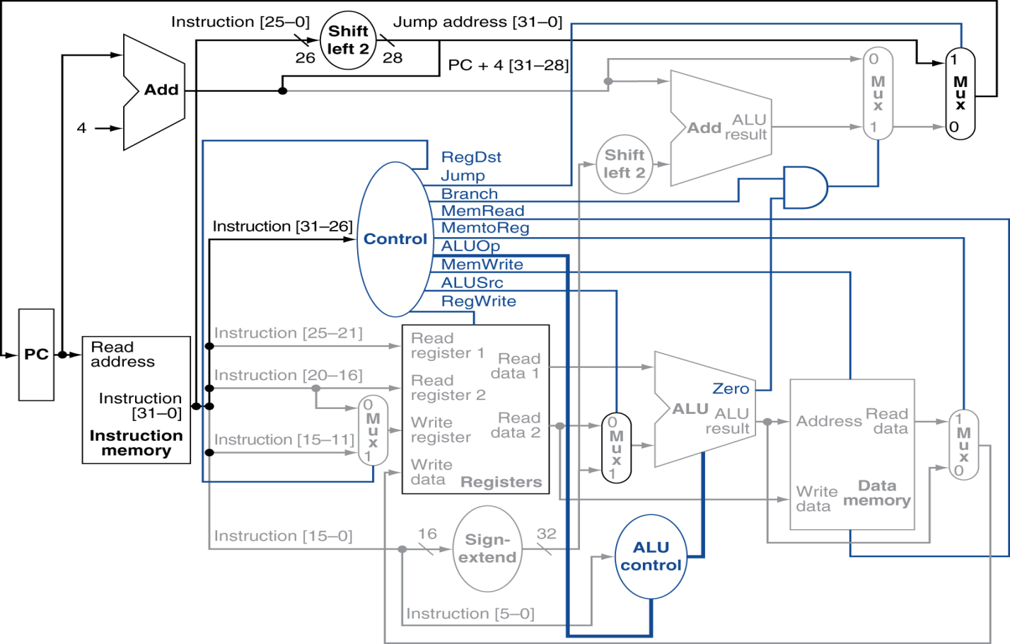

*Figure 1: Block diagram of a simplified single-cycle processor*

1. ***Multiplexer (MUX) description:***

A multiplexer is a combinational circuit which has multiple inputs and a single output. It is also known as a data selector as numerous inputs are taken to produce the single output. There is a maximum of 2n data inputs with ‘n’ selection lines which gives only one output in the end. There are different types of multiplexers such as 4x1 or 16x1 which have 4 and 16 inputs respectively and result in a single output. The schematic of the multiplexer function is shown in figure 2 given below.

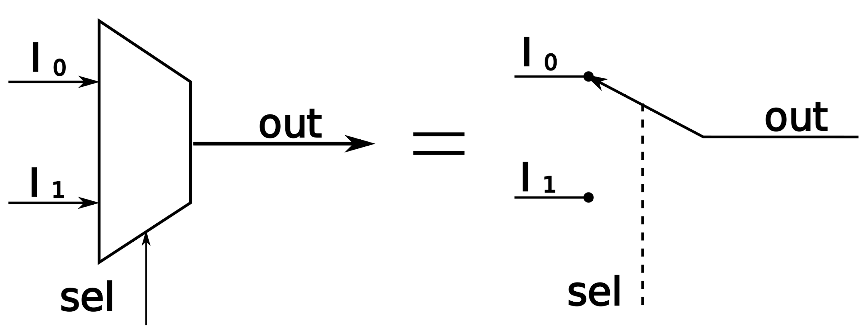

*Figure 2: Block diagram of multiplexer*

There are five multiplexers used in this project. Each multiplexer takes two inputs, either a zero (0) or a one (1) and then sends out a single value as the output. Some of the multiplexers used also have a selection line (*sel*).

**Multiplexer Module functionality:**

For this project, each of the multiplexers have 32 bit inputs and a 32 bit output, as well as a 1 bit selector. Since we don’t know the various values of inputs and selectors yet, we have coded the following basic functionality into our test multiplexer.

|  |  |  |  |
| --- | --- | --- | --- |
| **Input 1 (A)** | **Input 2 (B)** | **Selector (Sel)** | **Output (C)** |
| 32’b0 | x | 1’b0 | 32’b0 |
| 32’b1 | x | 1’b0 | 32’b1 |
| x | 32’b0 | 1’b1 | 32’b0 |
| x | 32’b1 | 1’b1 | 32’b1 |

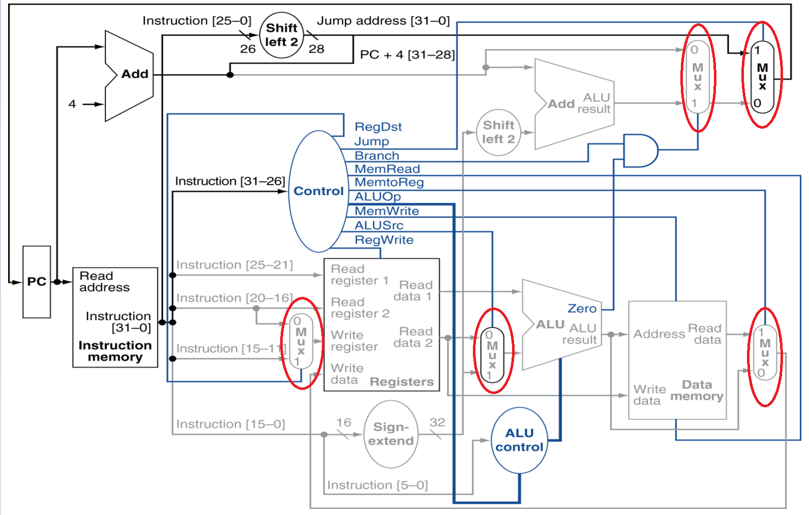

*Figure 3: Multiplexers in the processor*

**Multiplexer Simulation Results:**

From these results, we can see that our code works with the testbench values given. When the selector is 1’b1, the multiplexer chooses B (32’b101) as the output C. When the selector is 1’b0, the multiplexer would choose A as the output C.

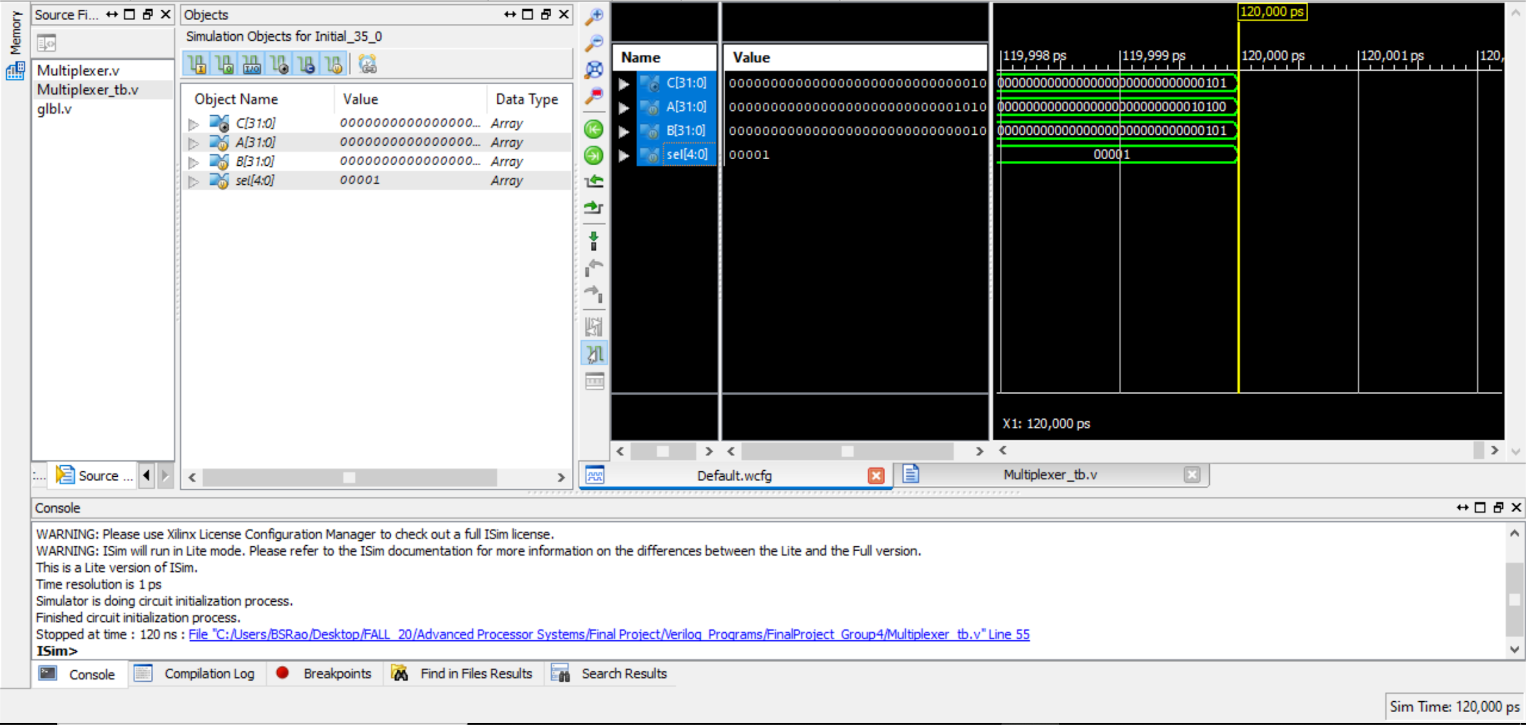

*Figure 4: Simulation result of multiplexer module*

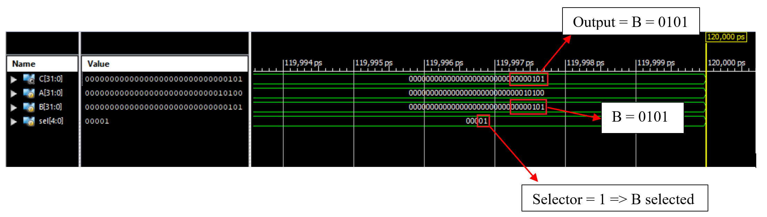

*Figure 5: Example simulation result*

1. ***Adder description:***

An adder circuit is used to perform the addition of two inputs. The two specific types of adders include the half adder and the full adder. The half adder binary circuit produces the result of addition of two binary digits. It leads to two terms as the output which are the sum and carry values. The drawback of using a half adder is that the carry-in bit is not taken into consideration when dealing with multiple data bits. The figure below (figure 6) gives an outline of the truth table of a half adder. The equations resulting in the output values is also shown as follows:

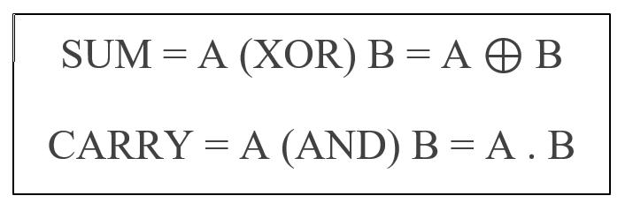

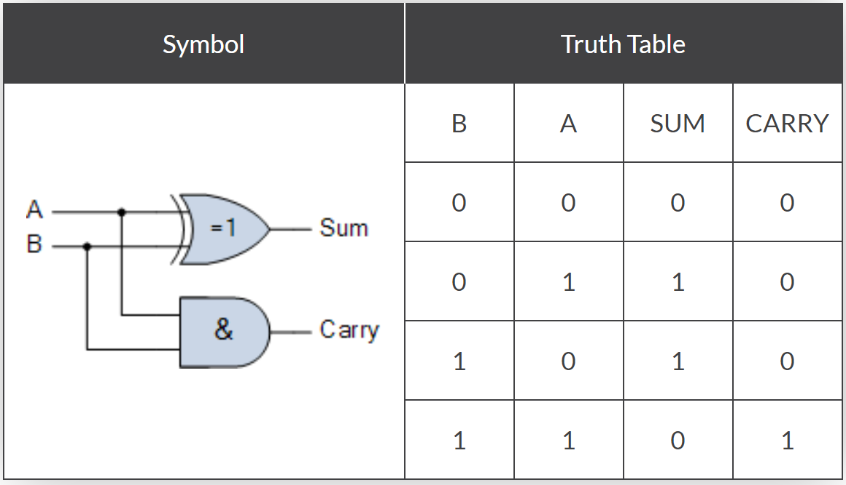

*Figure 6: Truth table of a half adder*

The full adder varies from the half adder by an additional input line. Here, there are two data inputs and a third input for the carry-in component. This carry-in (C-in) input is used to get the carry bit from the previous logic circuit. The full adder functions similar to the half adder but with three binary inputs and generates a carry-out term which represents the carry bit of the most significant digit. The full adder can be formed by the combination of two half adder circuits. A boolean expression of the full adder is given as follows:



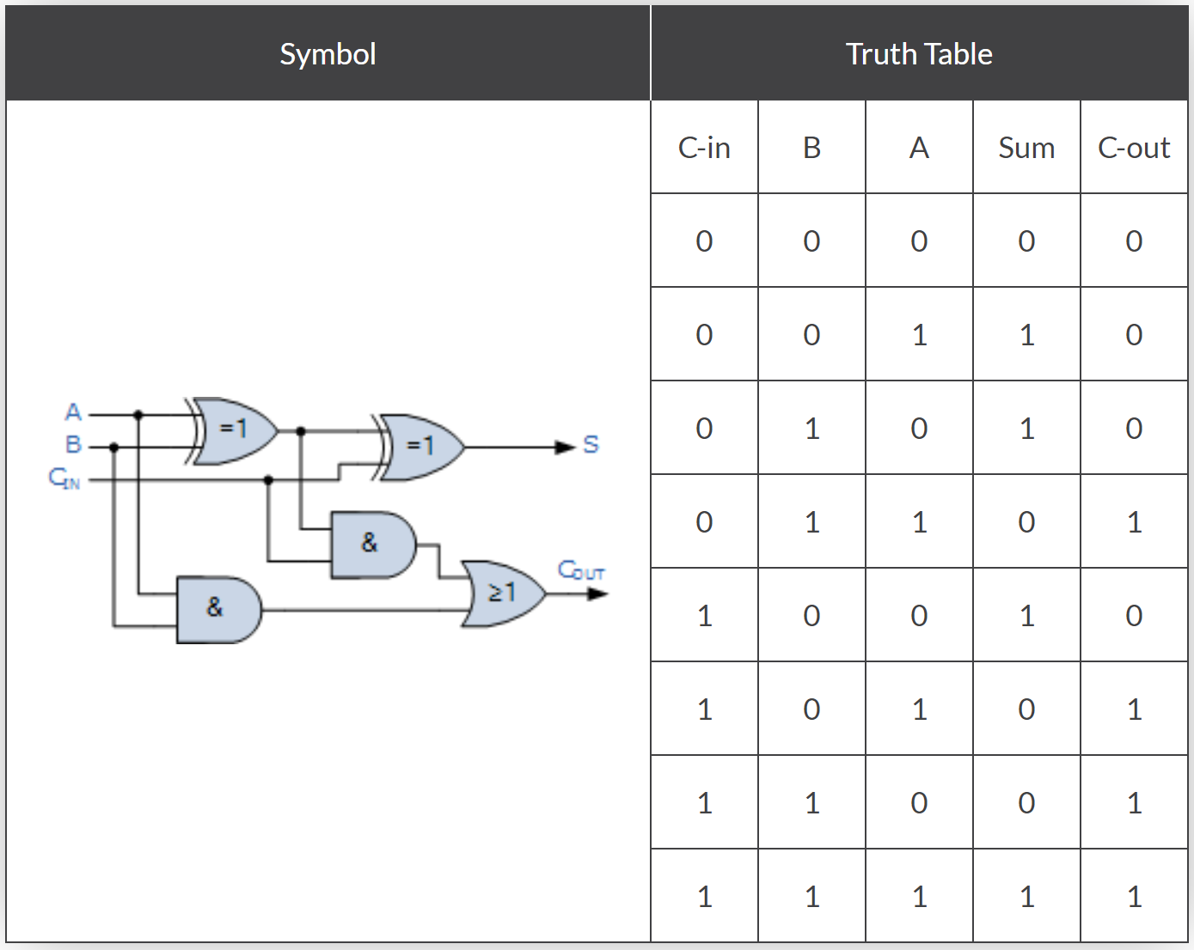

*Figure 7: Full adder truth table*

The truth table of the full adder is shown in the figure above. A representation of a combination of adders is shown in Figure 8 given below.

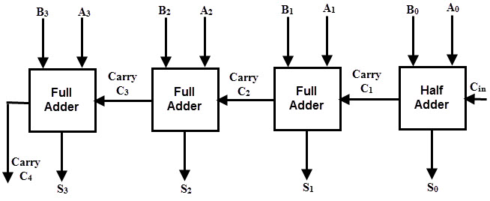

*Figure 8: Block diagram of Adder*

**Adder Module functionality:**

There are two adders which have been used in the block design as shown in figure 8. There are essentially two inputs and a single output to each of these adders. The adder used in this module has been created in multiple stages. From the half-bit adder, it has been developed into the 1 bit adder and then a 4-bit adder which has then been developed into a 16-bit adder and finally this was combined to form a 32-bit adder.

32- Bit Adder

The goal of this section is to design a 32-bit adder. To create a 32- bit adder, our system needs two 16 bit adders. Developing a 32- bit adder requires us:

developing a half adder

developing a full adder

developing a 4-bit adder

developing a 16-bit adder

Our first step is to develop a full bit adder using two half bit adders. We know that a half adder has two inputs and two outputs. When joined together, our system will have two inputs, a carry input, a carry output and a sum output.

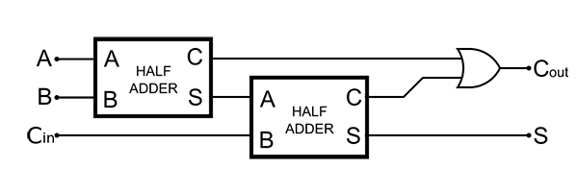

*Figure 9: Full- adder created with two half adders*

To create a 4-bit adder, we must call out our full adder four times. Therefore our system will have 8 inputs, 4 carry inputs, 4 sum output, and 1 carry out.



*Figure 10: 4-bit adder created with 4 full adders (cascade of four full adders)*

To create the 16-bit adder, we must call out the 4-bit adder four times. The 32 bit adder will then call out the 16 bit adder twice.

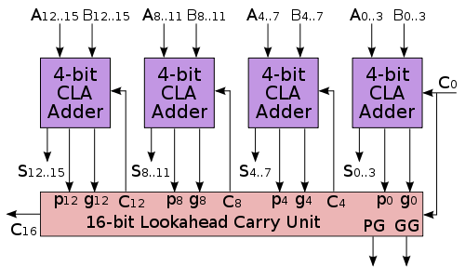

*Figure 11: 16-bit adder created with four 4-bit adders*

**Adder Simulation Results:**

From the adder simulation results shown below, we can see that the adder takes two 32-bit inputs for the terms with one 1-bit number for carrying, and produces a 32-bit sum with a one-bit carry-out as outputs. The two term inputs are named ‘a’ and ‘b’, and the carry input is c_in. The sum output is named ‘sum’ and the carry-out bit is named ‘c_out’.

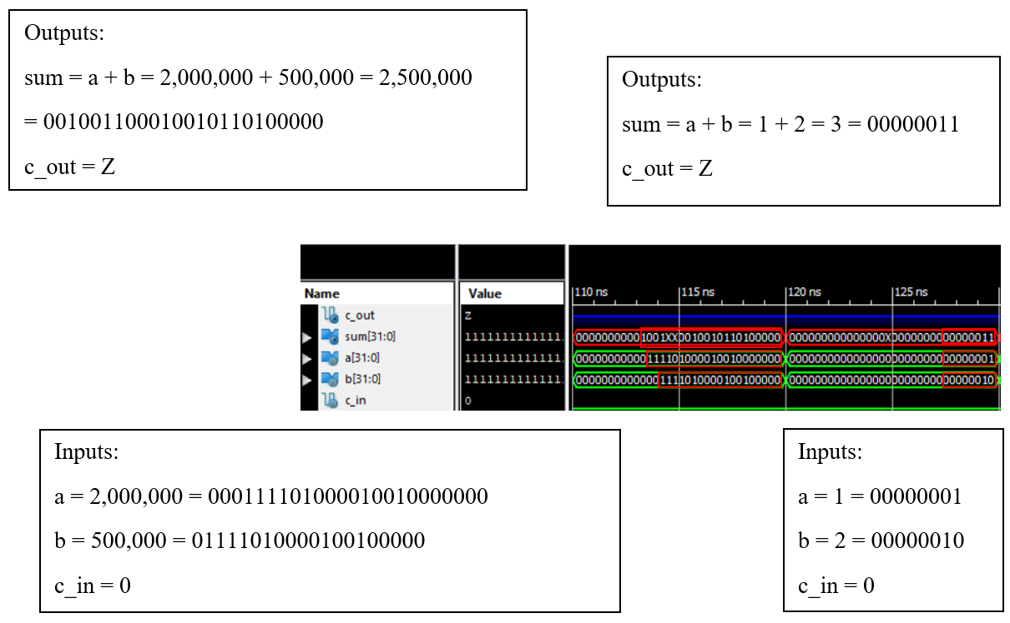

*Figure 12: Adder simulation result part 1*

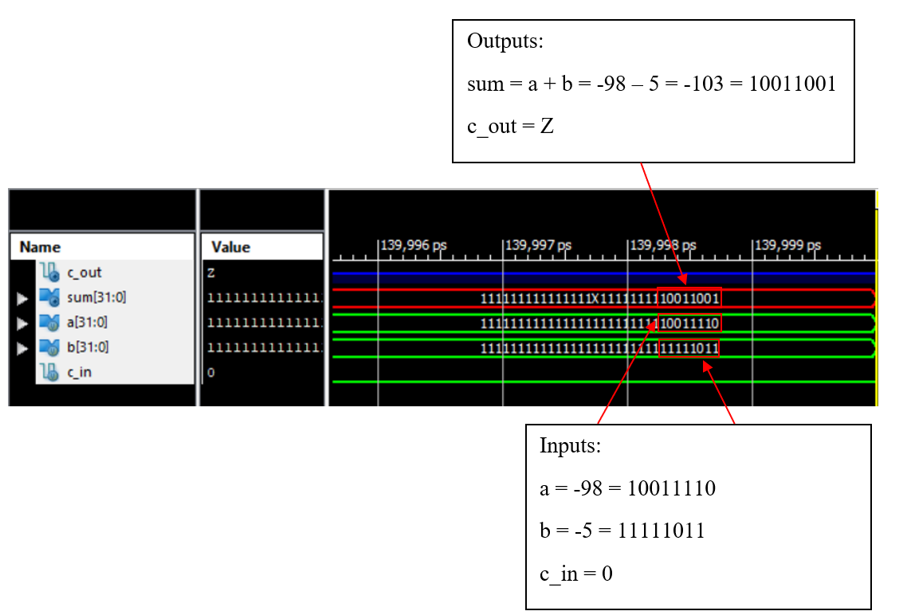

*Figure 13: Adder simulation result part 2*

**III.  *Shift register description: (Shift left by 2)***

The second module that we created this week was a shift register. Shift registers take an input and shift the bits of the input left or right by a specified amount. In our case, this shift register takes a 26 bit input and shifts it 2 bits to the left. However, since the output of the shift register must be 28 bits, 2 bits are also padded on to the beginning of the original input. Shifting and padding the extra bits with 0’s is known as a binary shift operation.

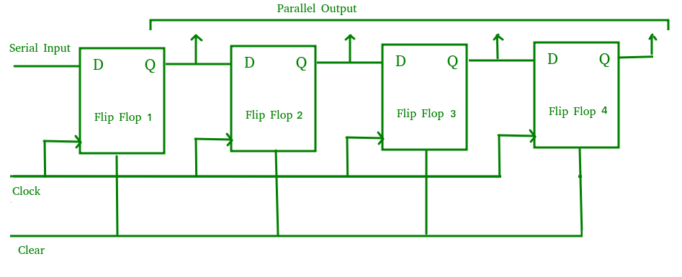

*Figure 14: Block diagram of Shift Register*

**Shift register module functionality:**

The binary shift register that we have designed takes in a 26-bit input, shifts it twice to the left, then pads with an extra two 0 bits in order to form a 28-bit output. There is another shift register that is circled in blue in *Figure 8*, that takes in a 32-bit input and shifts the input 2 bits to the left. The base design that we created can be easily expanded to take a 32-bit input simply by changing the input values in the instantiation file. We will have a better idea of the specific input and output that the 2nd shift register handles once we create the sign-extend and instruction registers.

The below figure gives an overview of the modules discussed this week (Figure 15).

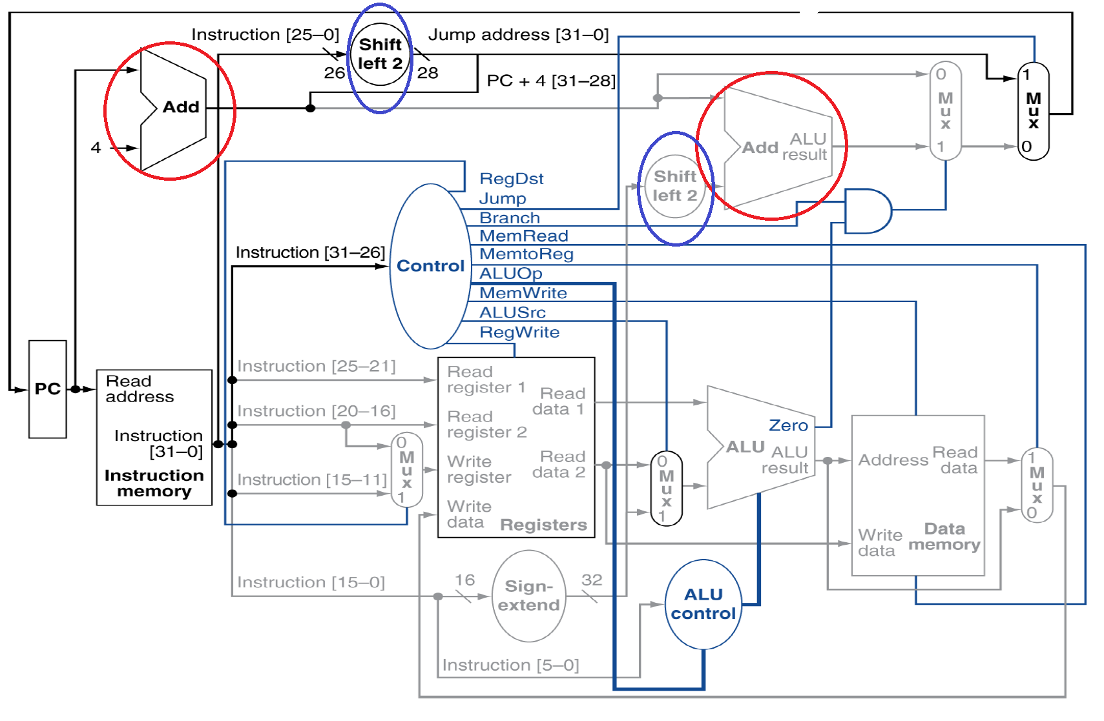

*Figure 15: Adders and Shift Registers in the processor*

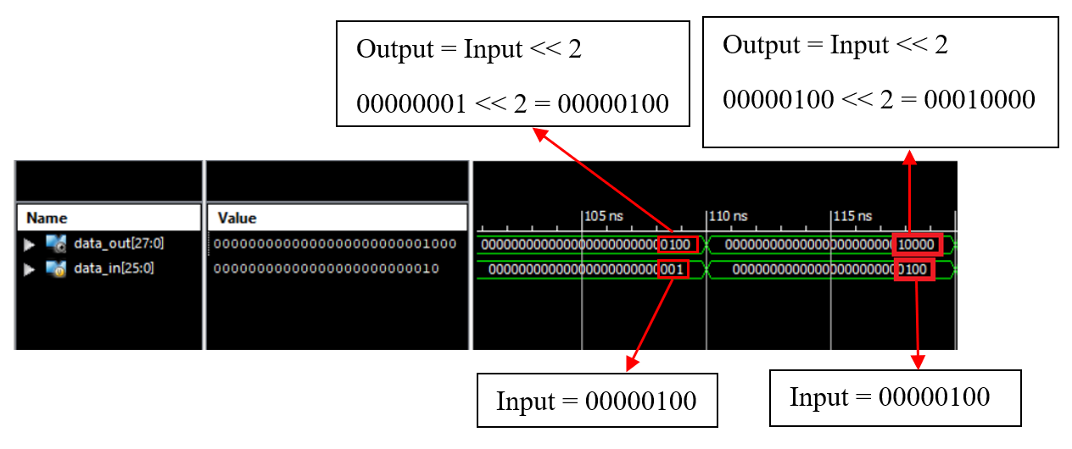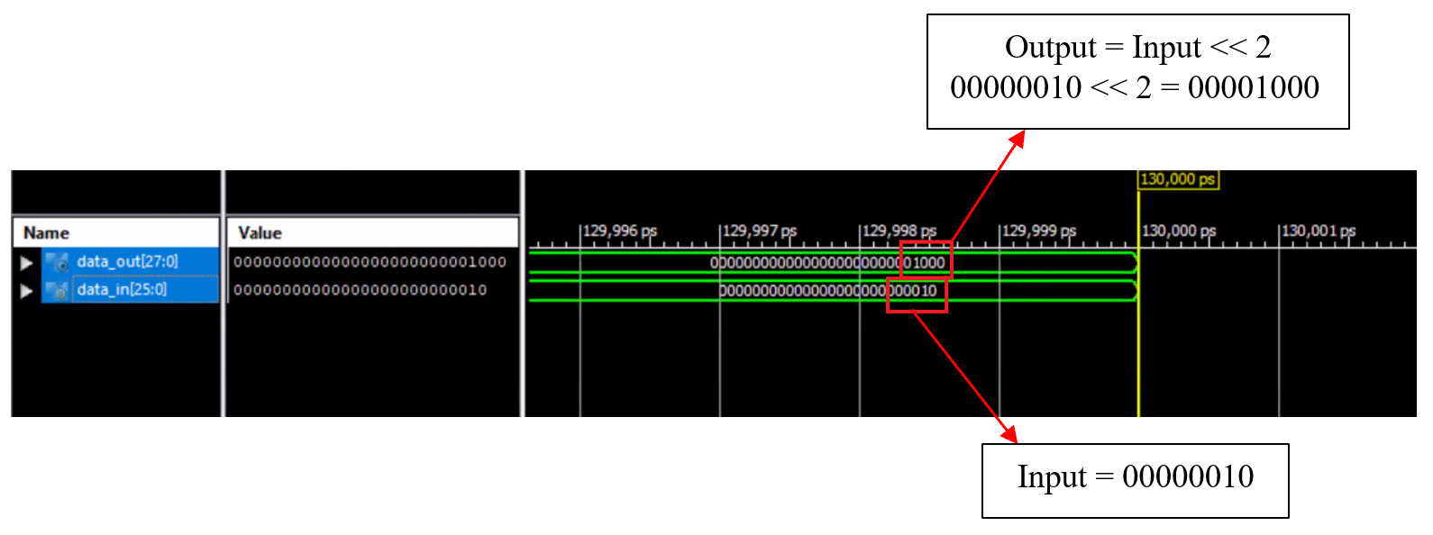

*Figure 16: Shift Register simulation result*

**Shift register Simulation Results:**

From the shift register simulation results shown above, we can see that the shift register takes a 26-bit number as its input and outputs the input shifted left by two bits using an arithmetic shift. Since the arithmetic shift adds two bits to the least significant bit of the input, the output will be two bits larger, at 28 bits.

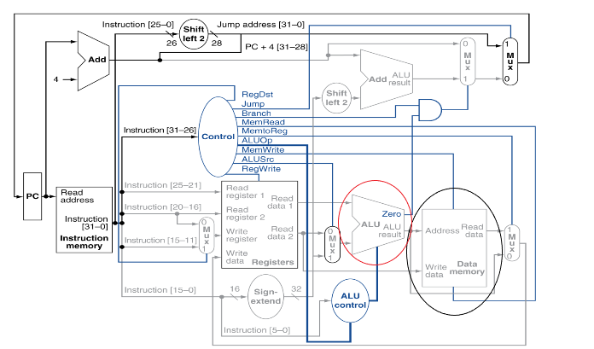

*Figure 17: Block diagram featuring ALU and Data Memory modules*

**IV. Multiplier description:**

This module takes in two inputs and multiplies them. The output of this module is the product of these two inputs. The output product bit length will be the sum of the two input’s bit lengths. This module can later be expanded to include various ALU operations, such as addition, subtraction, division, shifting and more.

*Figure 18: Block diagram of a 32 bit shift multiplier ALU*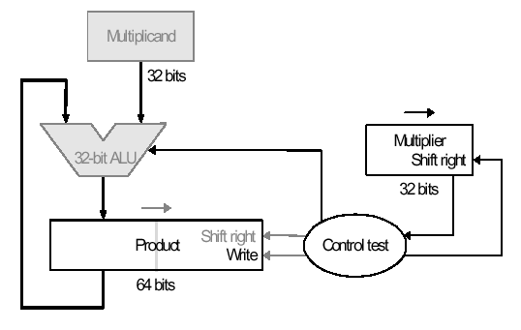

**Multiplier Functionality:**

The multiplier modules used to calculate the product of two operands. This specific multiplier takes in two 16 bit inputs and calculates the resulting 32 bit output product. This module works by using the shift multiplication method. The procedure of shift multiplication can be seen below in *Figure 18.*

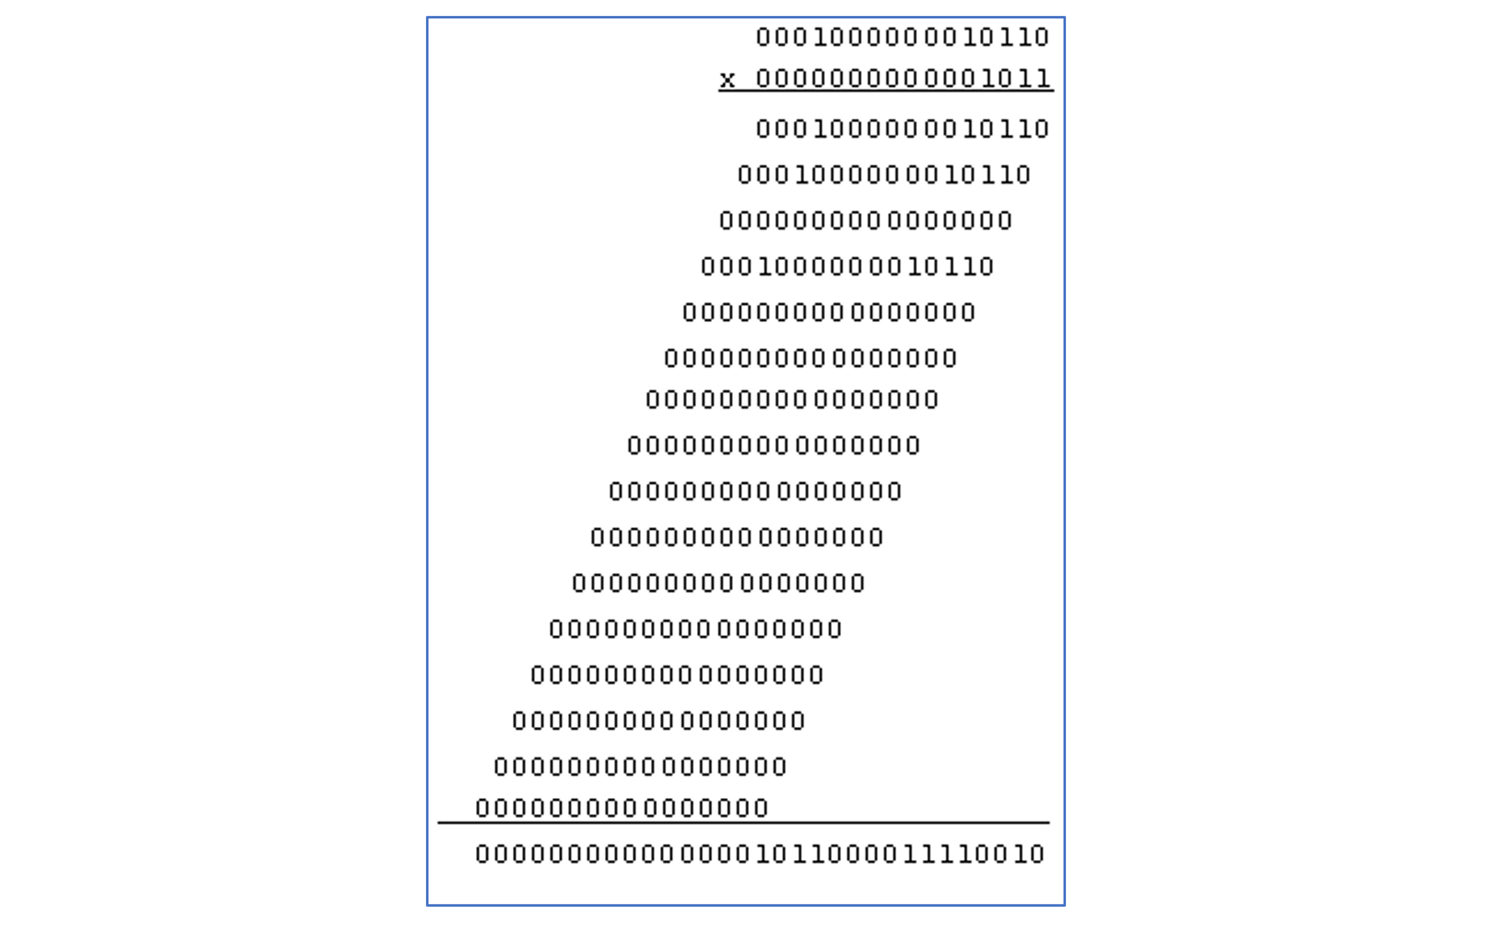

*Figure 19:16 bit multiplication*

Using this method of shift multiplication in Verilog, we were able to simulate the results shown in the following section.

**Multiplier Simulation Results:**

From the adder simulation results shown below, we can see that the adder takes two 16-bit inputs for the multiplier and multiplicand, and outputs the 32-bit product of the inputs. For the first example the two inputs, a and b, are -3 and 4 in binary. As you can see, the output is -12 in binary. For the second example the inputs are 3 and 4, and the output is 12 in binary.

*Figure 20: Simulation result for the multiplier*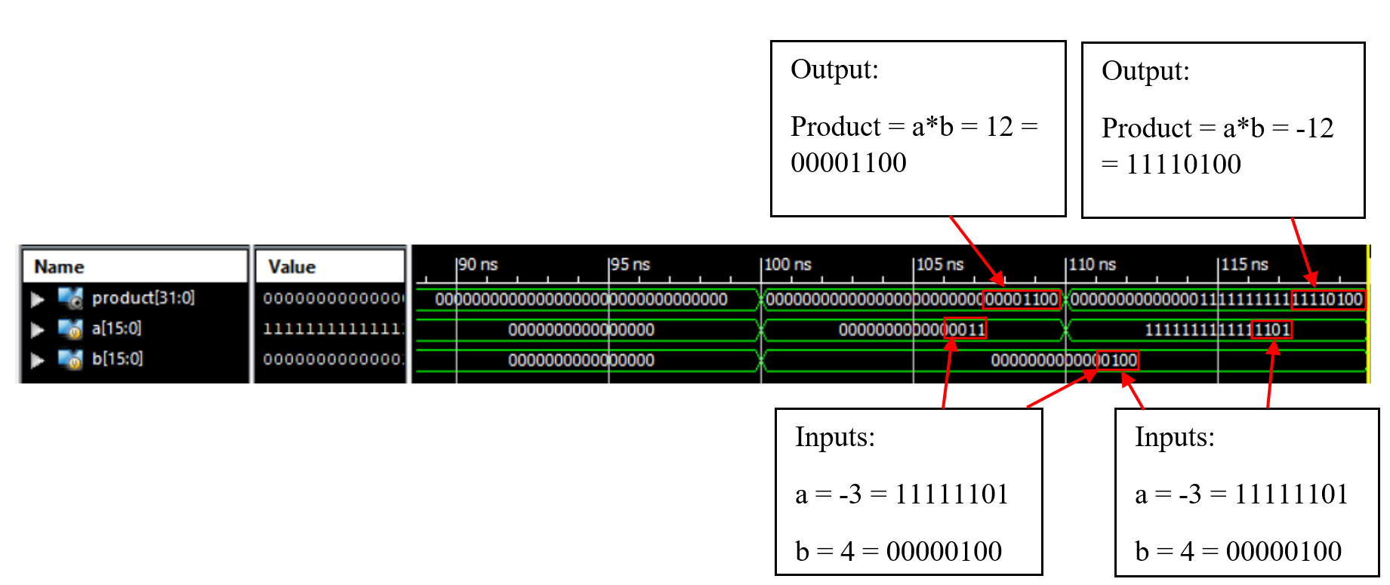

**V. Instruction Memory Description**

The first module of this section that we have created is the Instruction Memory. This module takes input from the program counter, then decodes this information by breaking it down and sending each segment out to the correct modules. The Instruction Memory provides crucial information to the registers and ALU which lets each module know what instruction to execute, as well as what data to execute the instruction on. Below is the block diagram of our processor showing where the instruction memory is located in the design.

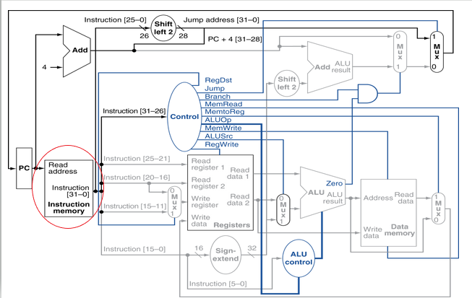

*Figure 21: Block diagram of Instruction Memory in the Processor*

**Instruction Memory Functionality:**

The instruction memory that we have designed takes in a 32 bit input from the program counter and decodes it into various segments, leading to 6 different outputs. The upper 6 bits [31:26] fed into the instruction memory are sent to the control unit. The next three 5-bit segments [25:11] are sent to the registers to provide read and write addresses. The final 16 bits [15:0] overlap in their values. The write register address [15:11] is included along with the ALU opcode [5:0] inside the input to the sign-extend register [15:0]. The combination of these 6 signals provides the total data out, allowing the processor to execute the given instruction.

**Instruction Memory Simulation Results:**

From the instruction memory simulation results below, we can see the 32 bit program counter input outlined in red. This PC signal is then split into small segments, each of which align with the 6 output signals described in the module functionality. The control signal, outlined with a white box, shows that the first 6 bits of the PC signal are stored in the CTL output. The yellow, pink, and light blue outlines show that the following 15 bits of the PC signal are sent out to the read and write registers. Finally, the dark blue and red outlines show that the final 16 bits of the PC input are stored in the sign-extend register, with the final 6 bits being sent as an opcode to the ALU.

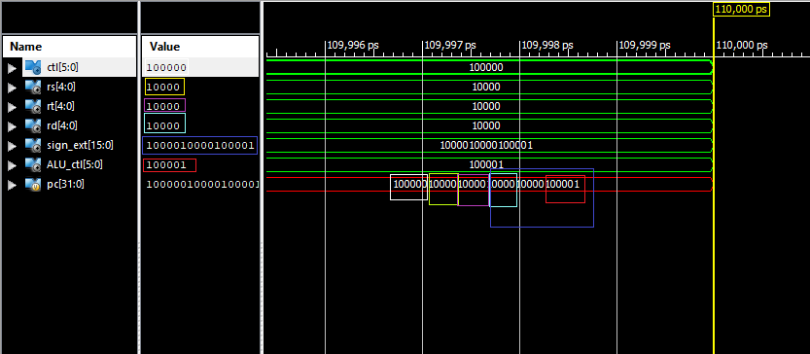

*Figure 22: Instruction Memory simulation result*

**VI. Program Counter (PC):**

**Program Counter Functionality & Description:**

The Program Counter, also known as the PC is a block which holds the address of the present instruction. It is a 32-bit register which stores the instruction address and updates it at the end of every clock cycle. Generally, the incrementation of the PC is done sequentially unless branch instructions are to be executed. The PC block is both read and written to. The PC is incremented by the adder which helps the PC to hold the address of the next instruction.

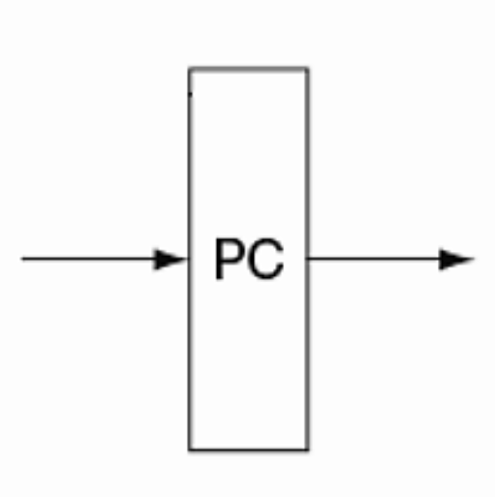

*Figure 23: PC element*

The address in the PC is utilized to fetch the current instruction from instruction memory. After the instruction is decoded and executed, the PC gets updated to hold the address of the next instruction. As MIPS instructions are word-aligned, we perform in the increment of the PC using (PC+4). Figure 24 shows the PC module in the single-cycle processor block diagram.

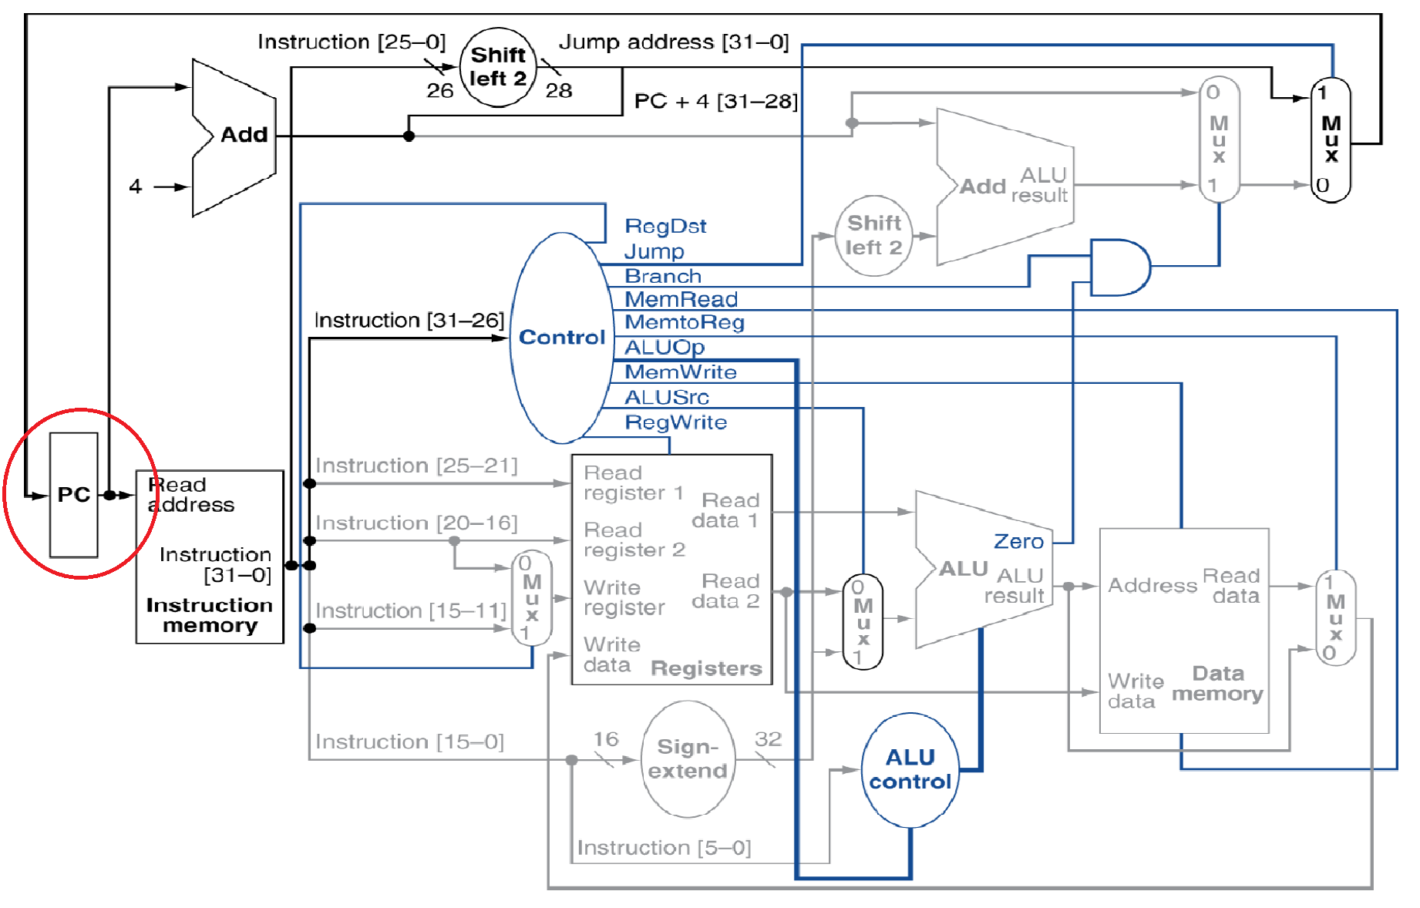

*Figure 24: Block diagram featuring PC module*

**Program Counter Simulation Results:**

As shown below in Figure 25, when reset is 1, the program counter (result) is 0. As shown below in Figure 26, when reset is 0, the program counter outputs the address input added to 4.

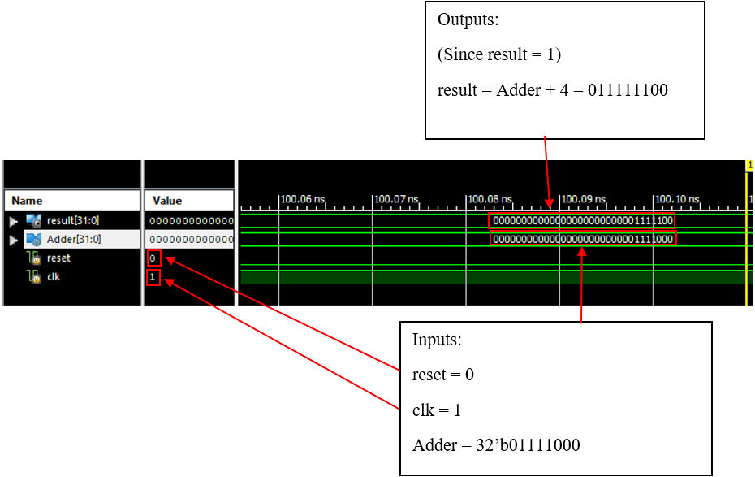

*Figure 25: PC simulation result 1*

*Figure 26: PC simulation result 2*

The purpose of the PC Counter is to store the address of the next instruction that will be carried out. Our test bench result shows that code achieved this goal. When the instruction gets fetched, reset is 0, the program counter increases by address +4. When a reset occurs the program counter is set to 0.

**VII. Data Memory:**

**Data Memory Description & Functionality:**

The data memory block acts as a function to read and write data to and from the memory. There are essentially two inputs, one being the address of the memory location which we need to access (*Address*) and the other is the data to be written to the memory (*Write data*), whenever applicable. The output for this block is *Read data* which is the data read from the accessed memory location. The *MemRead* and *MemWrite* shown in the figure below (Figure 27) signals the read and write respectively. One of the inputs of the multiplexer is also connected from the *Read data* line of the data memory.

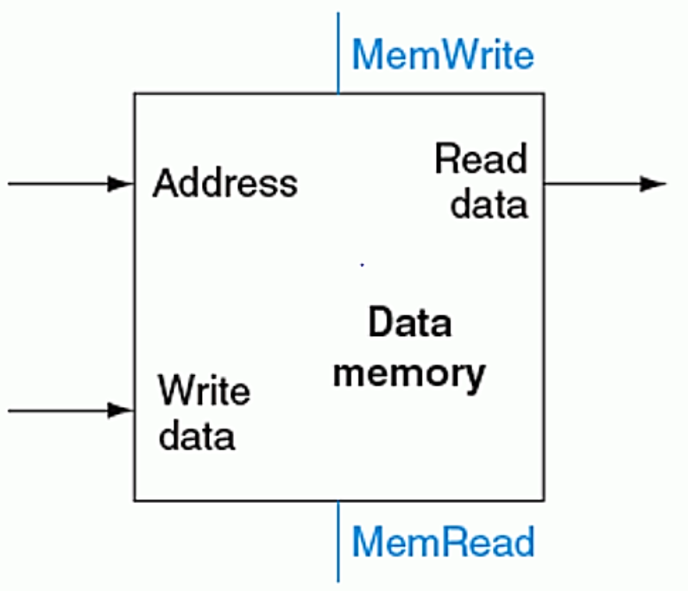

*Figure 27: Data Memory unit*

A block diagram of the single-cycle processor shown below highlights the data memory module given in Figure 28.

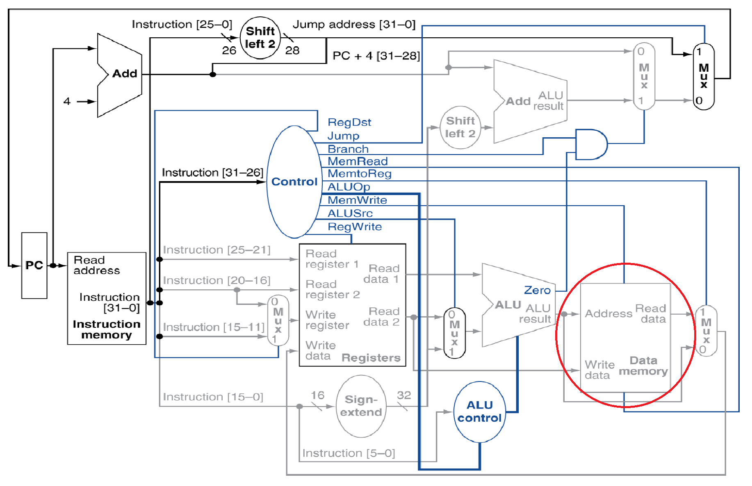

*Figure 28: Block diagram featuring Data Memory module*

**Data Memory Simulation Results:**

As shown below in Figure 29, while the clock is on, the memory address inputs are 32’b01 and 32’b010, respectively. For the first simulation, the memory write and read flags are 0 and 1, respectively. For the second simulation, the memory write and memory read flags are 1 and 0, respectively. The output, read_data, for both simulations is 32’b01.

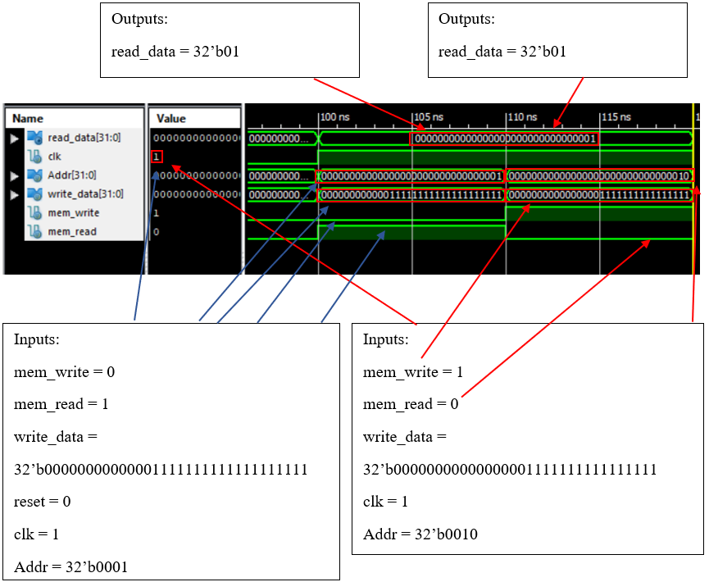

*Figure 29: Data Memory simulation result 1*

**VIII. Control block:**

**Control block Description & Functionality:**

It is the Control Unit's role in the CPU is to direct the operation of the processor. The control unit works by fetching the instruction from memory, then decodes the instruction into a command signal. The CPU then passes the instruction to the ALU. The ALU performs the appropriate calculations and sends the resulting values back to the control unit. The control unit sends these values to the corresponding program as output.

The opcode for each given instruction set is shown in Figure 30. Each opcode is assigned

to a specific output. The main output that makes up the control unit are the Register Destination, Memory to Register, ALU Src, Reg Write, Mem Write, Mem Read, Branch, Jump, and the ALU OP.

Code Set up:

A case statement was used to assign each output to the assigned opcode. At the rising clock edge, each output is assigned to the required bit shown in Figure 30.

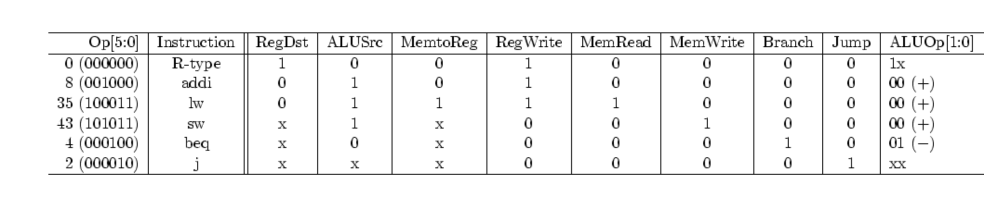

*Figure 30: Control Unit - Instruction Set Architecture*

*The R type instructions ( adder, subtractor, divider, and multiplier) all have the same opcodes.*

**Control block Simulation Results:**

Figure 31, shown the waveform for each assigned opcode. Opcode 000000 executed the R-type instruction. When the R-type instruction was executed, the output RegDst and the RegWrite were turned on. The 2-bit control signal ALUOp specified that the ALU operates the assigned arithmetic for the binary value 10.

When the Opcode changed to 100011 the load word instruction was executed. Here ALUSrc , MemtoReg, Reg Write, MemRead were turned on. The ALUOP calls the ALU to operate the assigned arithmetic for the binary value 00.

When the Opcode changed to 101011 the store word instruction was executed. Here ALUSrc and MemWrite were turned on. The ALUOP calls the ALU to operate the assigned arithmetic for the binary value 00.

When the Opcode changed to 000100, the branch equal to instruction was executed. The Branch output was the only function turned on. The ALUOP calls the ALU to operate the assigned arithmetic for the binary value 01.

When the Opcode changed to 000010, the jump instruction was executed. The jump output was the only function turned on. The ALUOP was assigned the binary value 00.

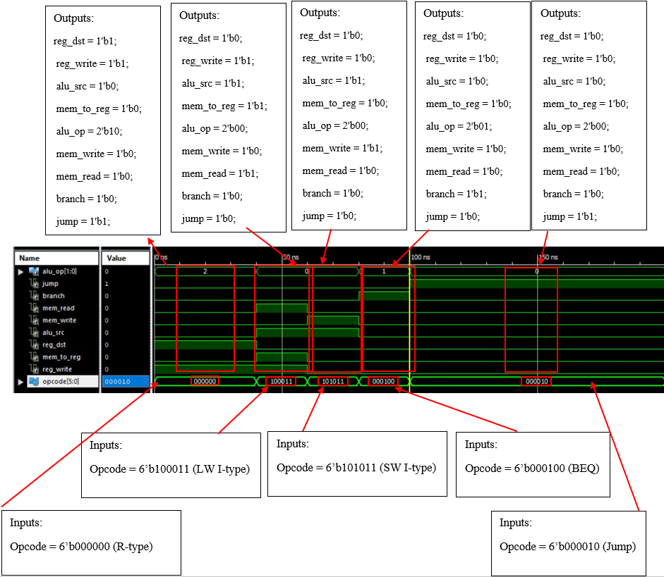

*Figure 31: Control Unit simulated result #1*

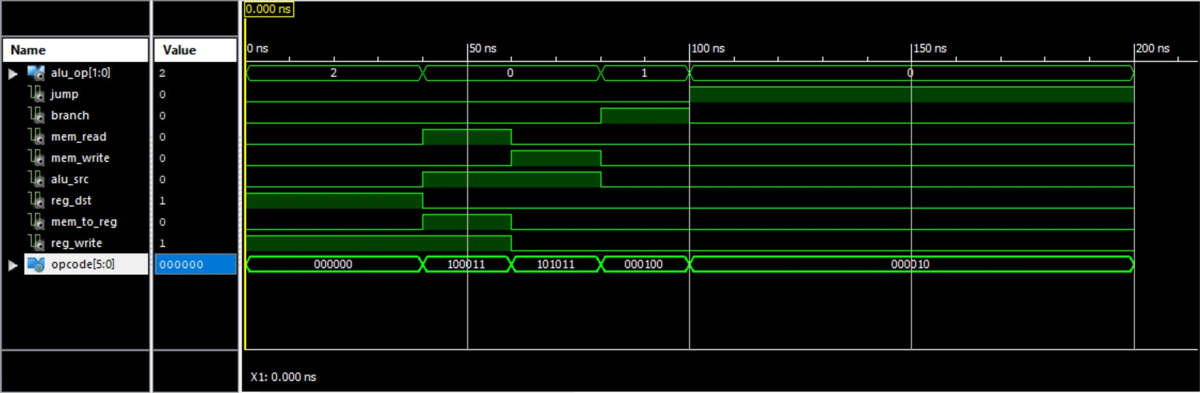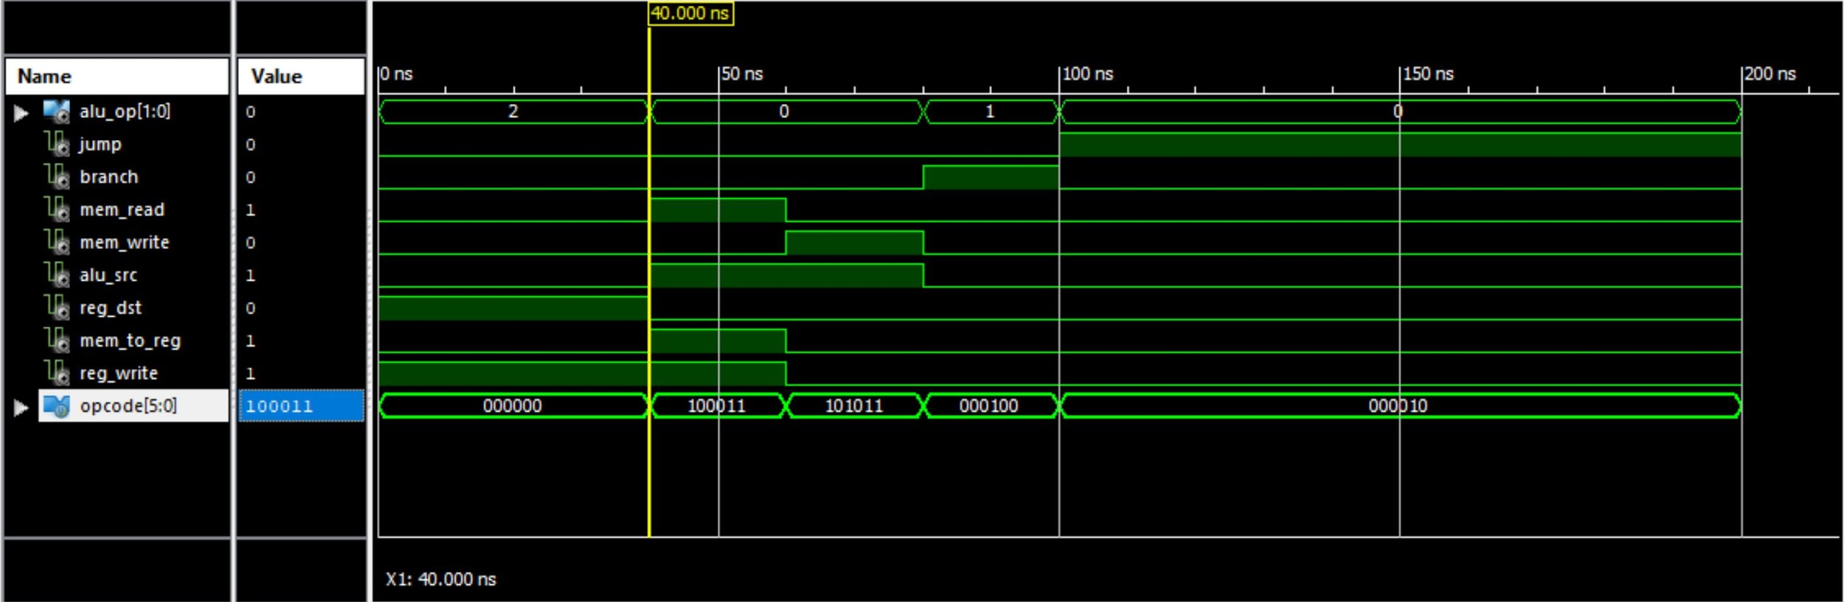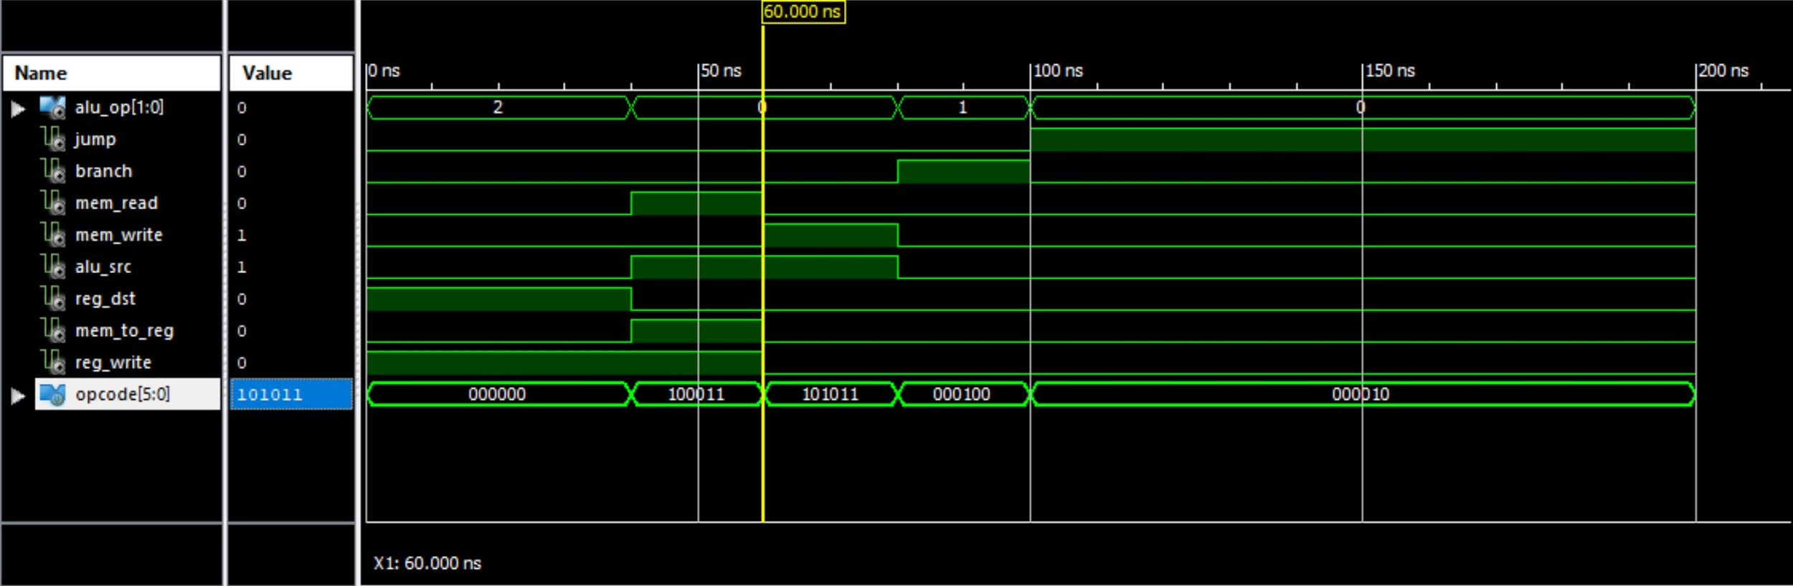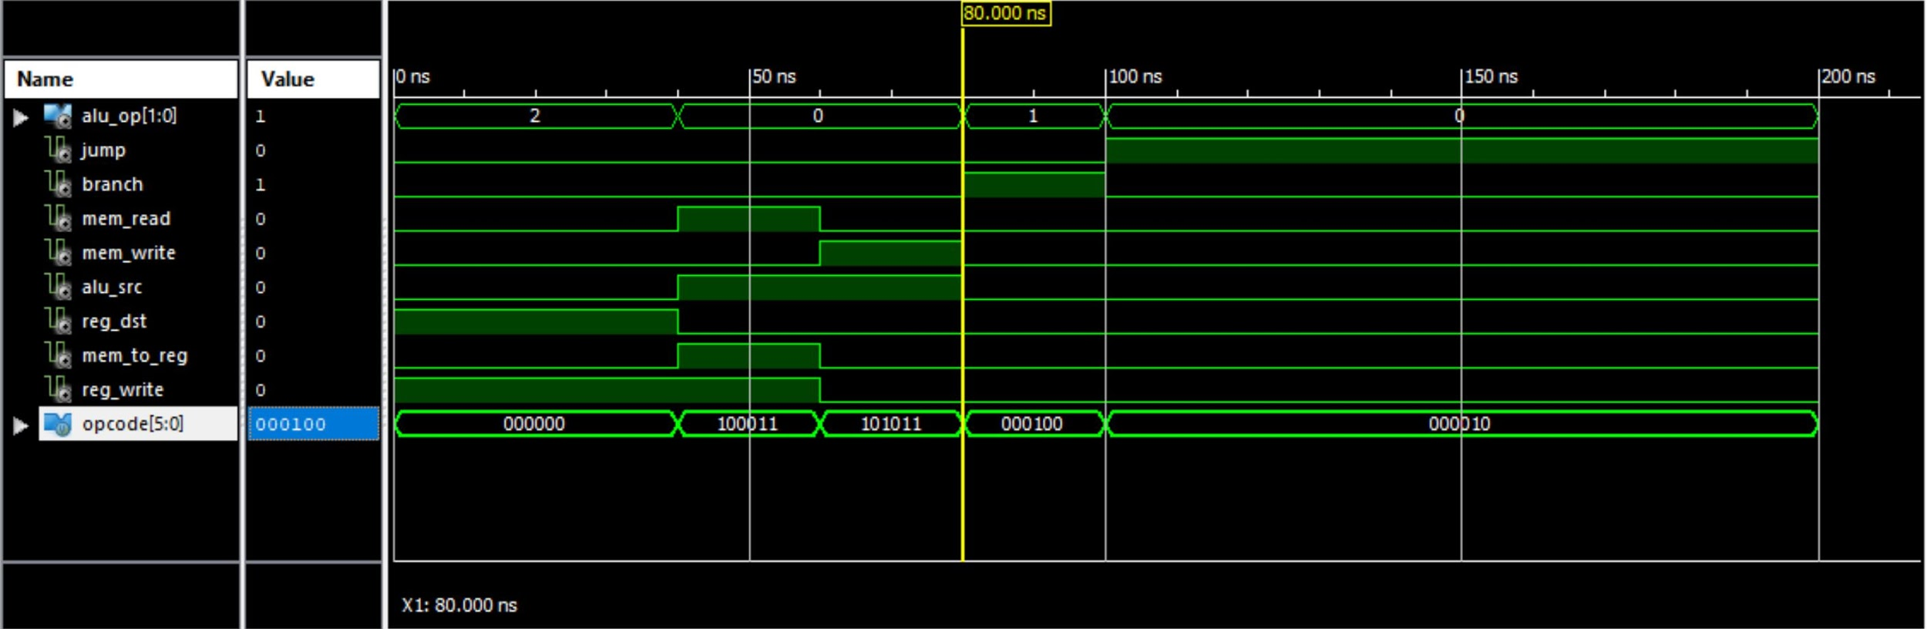

*Figure 31:C control unit simulation result 1*

**IX. Register block:**

**Register file Description & Functionality:**

The register block contains 32 general purpose registers. According to the register number any register can be read and written to the register unit. There are two 5-bit inputs which specify the register number to be read from and one 5-bit input which specifies the register number that is being written to. The register file can read from two registers and output two data outputs simultaneously. It utilizes a control signal, RegWrite. If RegWrite is high, data is being written to the register based on the register number that is input to the write register. If RegWrite is low, data is read from the registers specified by the read register inputs and output to the read data outputs. In a single-cycle processor, reading and writing from and two a register can happen in a single clock cycle.

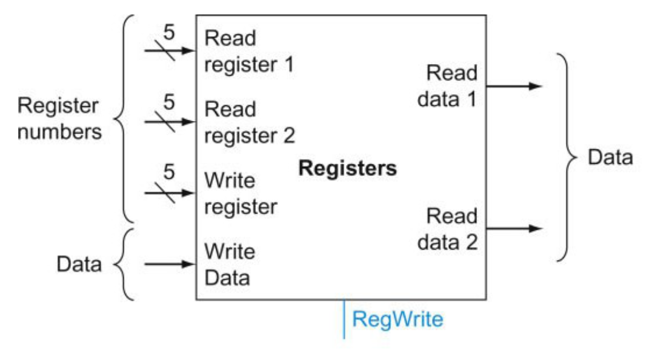

*Figure ##: Register block diagram*

**Register file Simulation Results:**

Our register file simulation work using the simulated testbench. For our first test case, we assigned 50 to write_data, we intend to store the 50 to address 10. Both reg1 and reg 2 will use register 10 to read the data. When the clock signal is high, 50 will be stored in register 10, reg1 and reg2 will send the output value to data1 and data 2. Our simulation shows each step worked properly, data1 and dat2 had 50 as its final value. For our second test case, we assigned 90 to write_data, we intend to store the 90 to address 3. This time only reg2 will be assigned for reading the data, reg2 will use register 3 to read the data.The output will be sent to data2. Because the clock was not in the high state, our write data did not store 90 into address 3. Therefore our output for data 2 was zero.

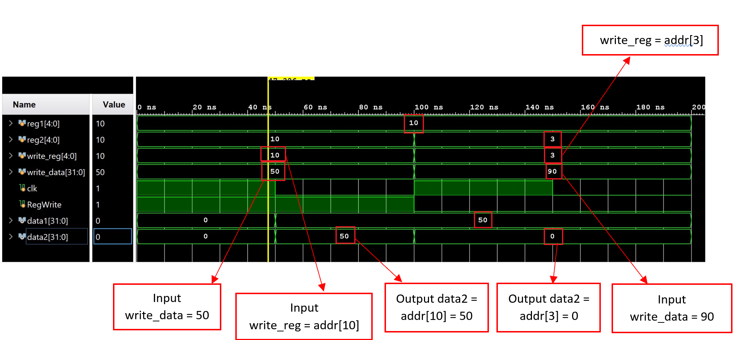

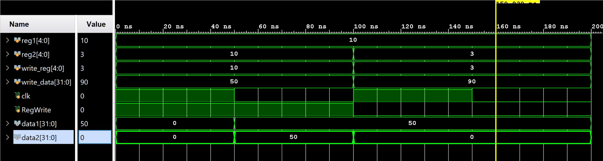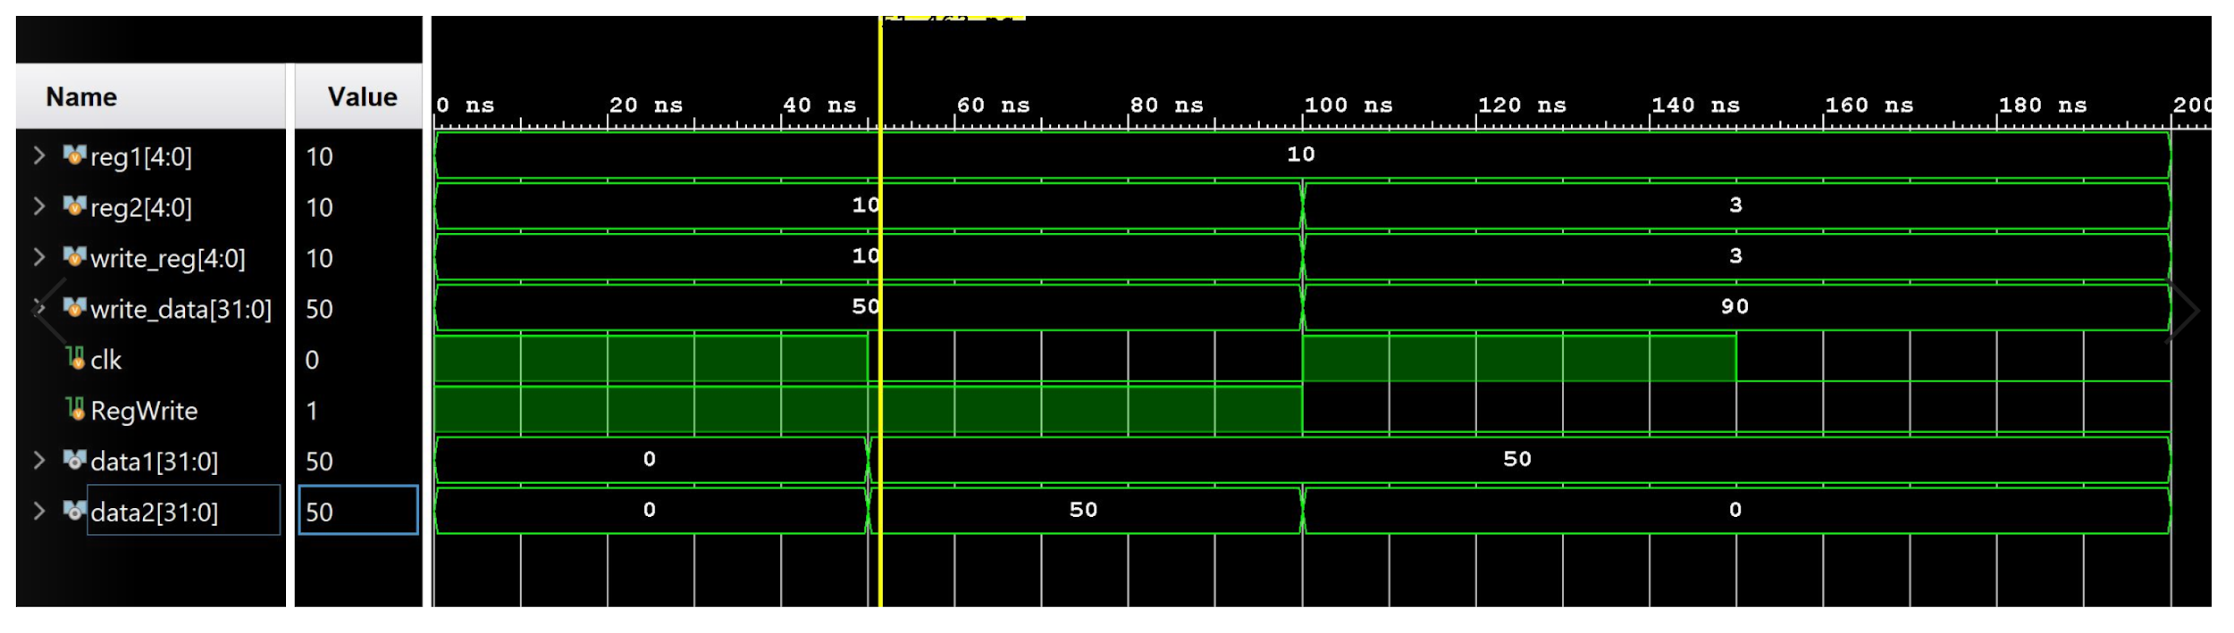

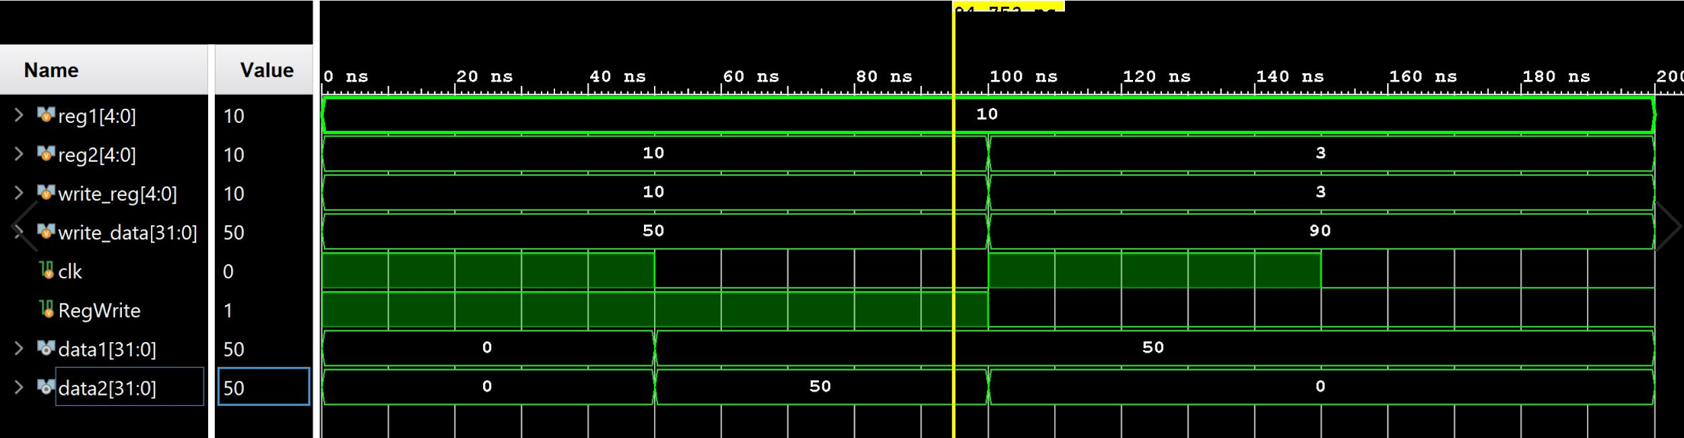

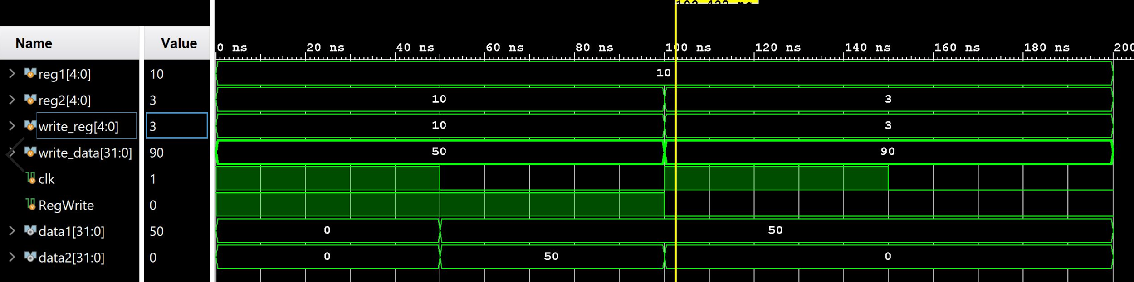

**X. Sign extend:**

**Sign Extend Description & Functionality:**

The sign extend module is one that takes in an input, reads the most significant bit of the input, then extends the length of the input by a certain amount of bits, based on its most significant bit. For example, if we want to extend an 8 bit input to a 16 bit output, and the input’s MSB is equal to 1, the output of the sign extension would be the original 8-bit input padded with 8 high bits attached to the front. A diagram of this process is shown in the image below.

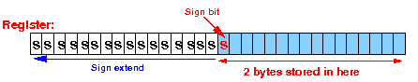

*Figure ##: Sign extension process*

The sign extension module in our processor takes in a 16 bit instruction from the instruction memory, extends the instruction to 32 bits, then feeds the output into a shift register which helps determine the next jump address for the program counter.

**Sign extend Simulation Results:**

As shown in the diagram below the input instruction is a 16 bit number (outlined in red) with a most significant bit of 1 (outlined in yellow). The output data_out is a combination of the input instruction (outlined in red) padded with 16 of the MSBs from the instruction (outlined in yellow).

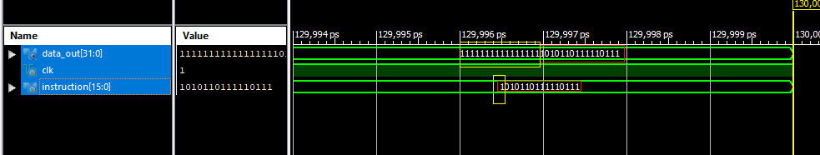

*Figure ##: Sign extension simulation results*

**XI. ALU block:**

**ALU Description & Functionality:**

The ALU block acts as a multiplexer that takes in two 32-bit digits as inputs, as well as a 3-bit control signal that determines the function being performed as well as the output. The functions being executed via the ALU are AND, OR, add, multiply, divide, SLT and subtract.The control signal ranges from binary 0 to binary 6 in the order previously given. The signal codes for each. The ALU receives one 32-bit input from the register block and receives the other 32-bit input from the register block as well, or as a 16-bit sign-extended input from the instruction memory. The ALU also contains a 1-bit *zero* signal that is only high if the output of the ALU is 0. The submodules for the adder, AND, OR, multiplier, divider, and SLT were instantiated into the ALU, and the subtraction function was implemented using a behavioral model. The functionality or the adder and multiplier were previously described, and the functionality for the AND, OR, SLT and divide will be described below.

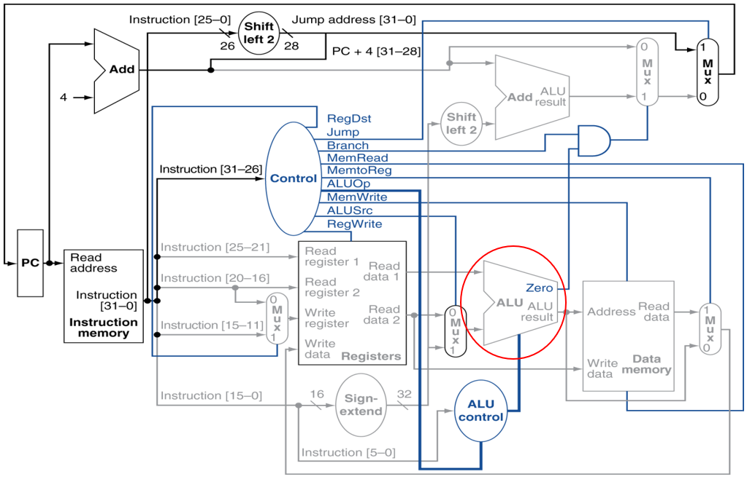

*Figure ##: Block diagram featuring ALU*

**ALU Simulation Results:**

As shown below in Figure ##, all six functions are simulated in the testbench. The AND function takes control signal 0, and numbers 4 and 5 as inputs. it outputs the bitwise AND operation of 4 & 5, which is equal to 4, as is shown in the output ,out, below. For the OR function, the ALU control input signal is 1, and the inputs to be evaluated are 4 and 5. The bitwise operation of 4 OR 5 is 5, which is shown in the output. For the addition function, the ALU control signal is 2, and the inputs to be evaluated remain the same. The operation 4 + 5 is 9, as is shown below in *out.* For the multiplication operation, the ALU control signal is 3, and the inputs to be evaluated remain the same as the previous operations. The operation 4 * 5 evaluates to 20, as shown below. For the division function, the ALU control signal is 4, and the inputs to be evaluated are 10 and 2. The expression 10 / 2 evaluates to 5 as shown below. For the SLT expression, the control signal is 5, and the inputs to be evaluated are 4 and 2. Since 4 is not less than 2, the output of the function is 0, as shown below. For the subtraction function, the ALU control signal is 6, and the inputs to be evaluated are 5 and 5. The expression 5 - 5 evaluates to 0, which is shown below.

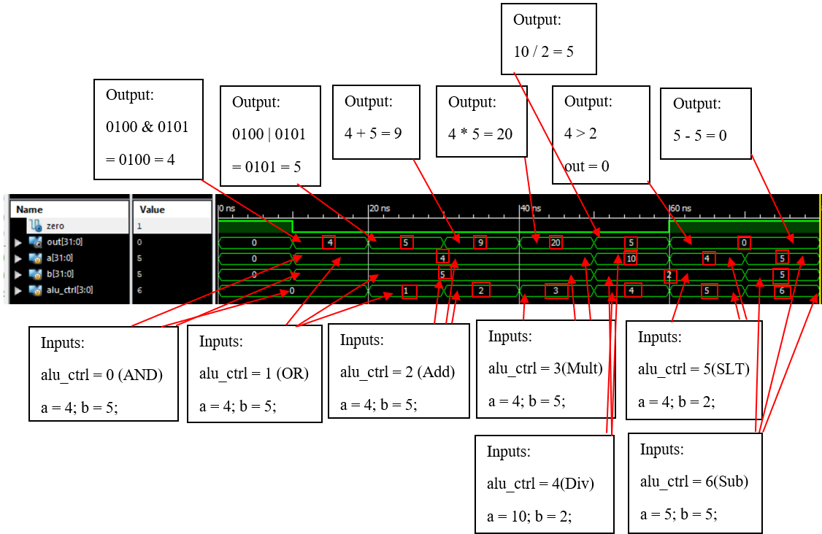

*Figure ##: ALU Simulation Result*

**Bitwise AND Description & Functionality**

The bitwise AND module performs the AND operation on two 32-bit inputs and outputs the 32-bit ANDed result of the two inputs bit-by-bit.

**Bitwise AND Simulation Result**

As shown below, on the left the two inputs are a = 11110000111100001111000011110000 and b = 000011111000011110000111100001111. The ANDed result of these inputs is 32’b0 as shown below. On the right, the two inputs are a = 11111111111111111111111111111111 and b = 11110000111100001111000011110000 and the ANDed result of these inputs is 32’b1 as shown below.

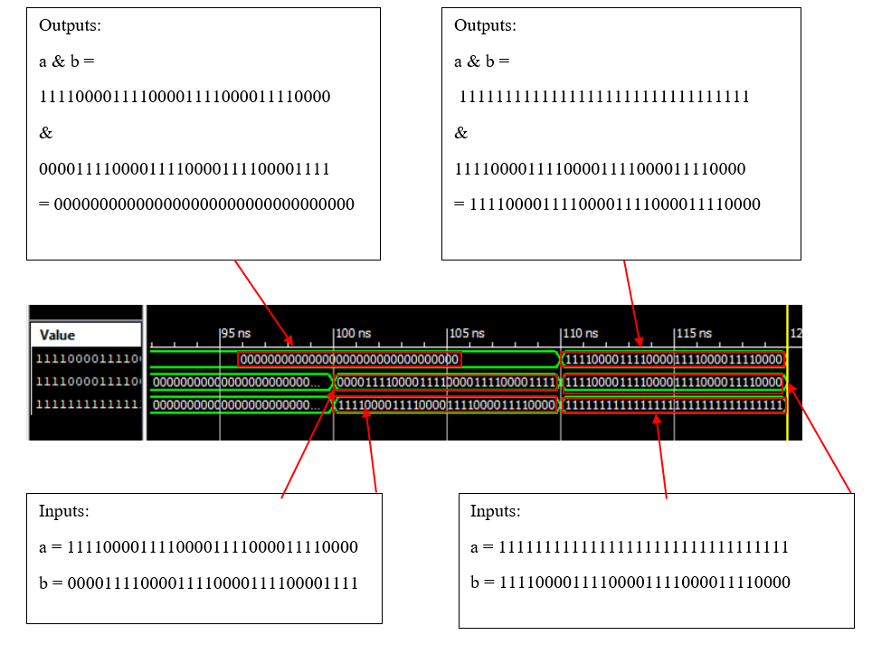

*Figure ##: ALU Simulation Result*

**Bitwise OR Description & Functionality**

The bitwise OR module performs the OR operation on two 32-bit inputs and outputs the 32-bit ORed result of the two inputs bit-by-bit.

**Bitwise OR Simulation Results**

The testbench simulation below outputs the ORed results of the inputs. On the left, the inputs are a = 10101010101010101010101010101010 and b = 01010101010101010101010101010101. The ORed result of these inputs is 32’b1 as shown below. On the right, the inputs are a = 32’b0 and b = 01010101010101010101010101010101 and the on the red result of the inputs is 01010101010101010101010101010101 as shown below.

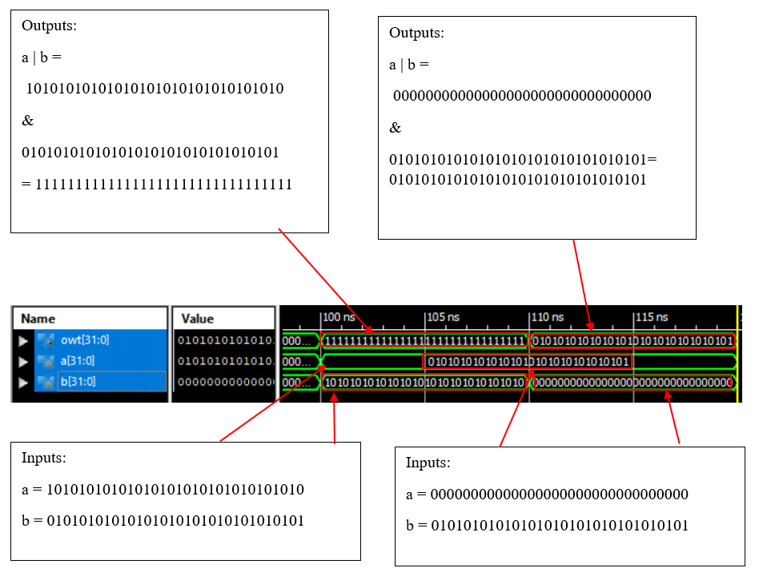

**Divider Description & Functionality**

The divider module takes in two 32-bit inputs of dividend and divisor and outputs two 32-bit outputs of quotient and remainder. Two registers hold the intermediate value for the division calculation, which are called int1 for the dividend and int2 for the divisor, and a register called init will hold the intermediate value for the remainder. The divider module first checks to see if the dividend and the divisor are negative, and if they are, they are subtracted from 0 to become positive. The intermediate variables for the quotient and dividend are then shifted left and the most significant bit of the dividend is appended to the least significant bit of the intermediate remainder. The dividend is then shifted left and the divisor is subtracted from the intermediate remainder. The raimader is then checked for negativity, and if it is negative, the least significant bit of the intermediate dividend is set to 0 and the intermediate divisor is added to the intermediate remainder. If the intermediate dividend is positive, the lsb of the dividend becomes 1. The most significant bit of the dividend and divisor are then checked for negativity. If they’re both negative, the quotient takes the intermediate value of the dividend, and the remainder takes the negative of the intermediate value of the remainder. If only the divisor is negative, the quotient takes the negative of the intermediate value of the dividend and the remainder takes the negative of the intermediate value of the remainder. If only the dividend is negative, the quotient takes the negative of the intermediate value of the dividend and the remainder takes the negative of the intermediate value of the remainder. The process repeats through each bit from bit 0 to 31.

**Divider Simulation Results**

The testbench simulation results shows the results of the dividend input divided by the divisor inputs, which are stored in the remainder and quotient outputs. The inputs below are 25 and 5 for the dividend and divisor, respectively. The result of the operation 25/5 = 5, with no remainder. The result of this is shown below.

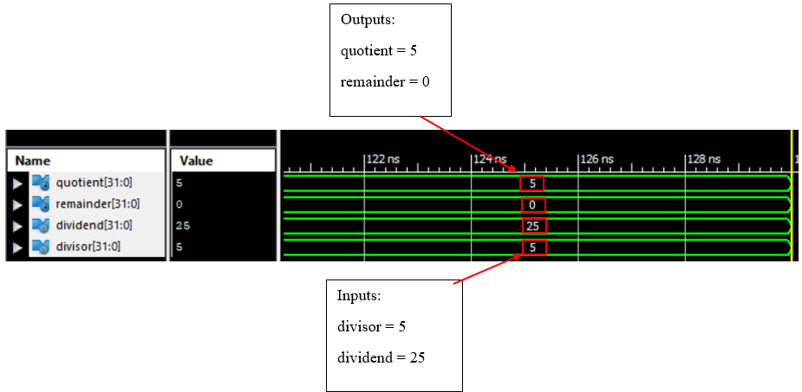

**Set on Less Than (SLT) Description & Functionality**

The SLT module takes in two 32-bit inputs, a and b, and outputs a 32-value, val. If a is less than b, value is equal to 1, otherwise, value is equal to 0.

**Set on Less Than (SLT) Simulation Results**

For the SLT operation on the left, the inputs a = 3 and b = 4 are compared. Since 3 is less than 4, the output val is set to 1, as expected. For the operation on the right, the inputs a = 4 and b = 3 are compared. Since 3 is not less than 4, the output val is set to 0, as expected.

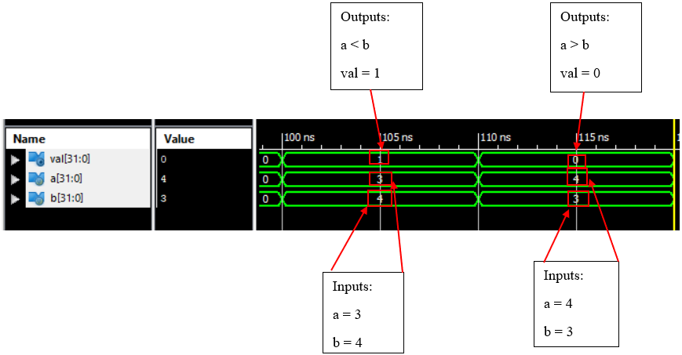

**Procedure: (Final program)**

We have successfully completed all the modules and tested each phase with the respective test benches. The compilation of all the modules was approached with instantiation of all the wires according to the block diagram as shown below.

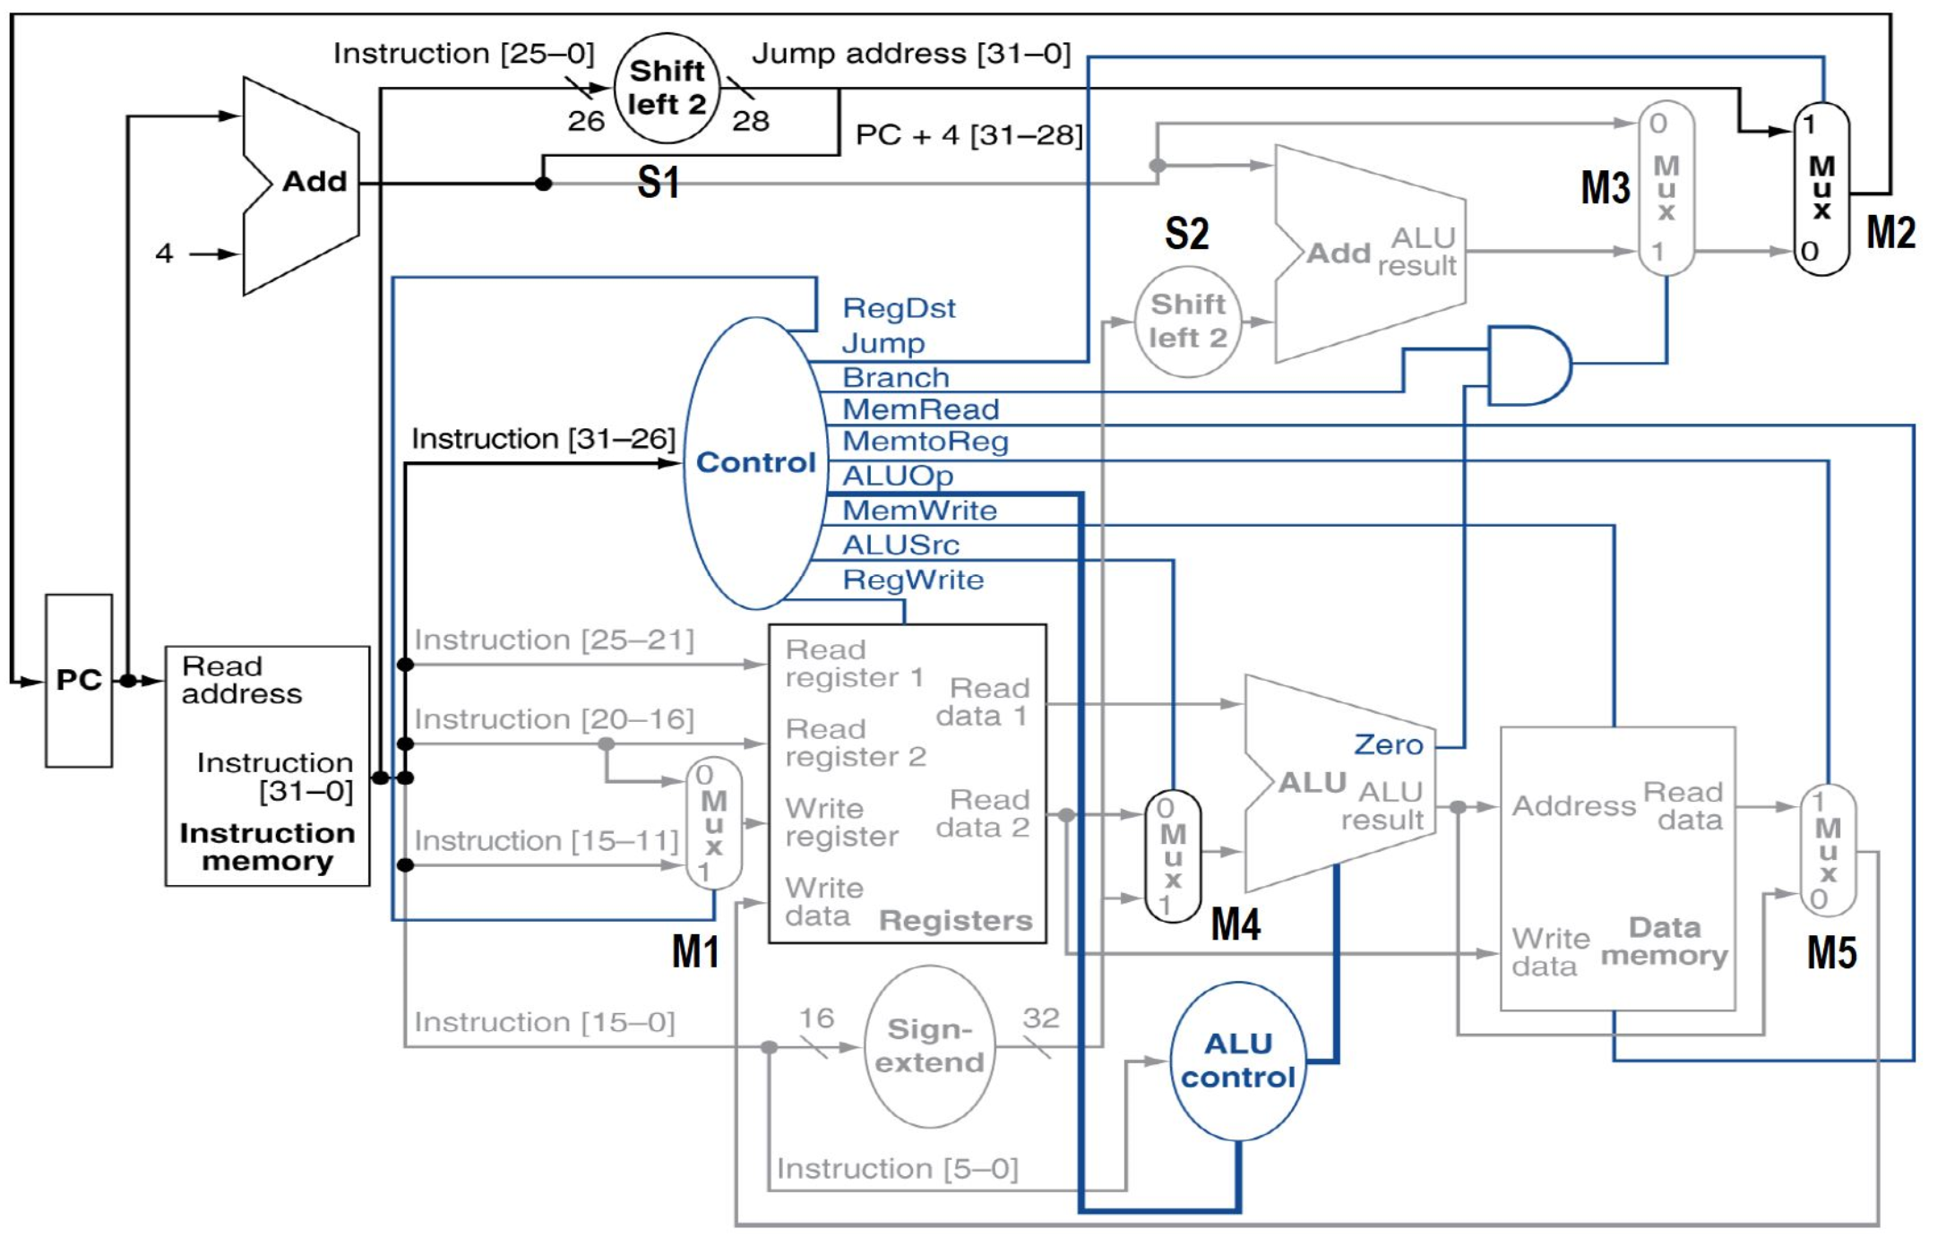

Our objective was to combine all the modules in order to evaluate any expression. The test program was to evaluate the expression { y = ((b - a) + (d - c)*e)/f } where the values of the variables are shown as follows. The values have also been represented in the hexadecimal notation.

a = 1000 = 0x3E8

b = 200 = 0xC8

c = 300 = 0x12C

d = 400 = 0x190

e = 100 = 0x64

f = 3 = 0x03

These variables are initially saved in the data memory block at memory locations from the index of 0 to 5. The output ‘y’ is also saved to the data memory at any suitable memory address. The expression is converted into a sequence of instructions which are then saved to the instruction memory. The address of the first instruction in the sequence is assigned to the program counter (PC) at the start of the program. This ensures that the sequence is executed from the beginning in the proper order.

After the variables are assigned to the respective values, the temporary registers are used to load in the instructions in hexadecimal representations. Thus, each MIPS instruction is converted into the hexadecimal notation and executing them one after the other builds up the required expression to be evaluated. Finally the result is then supposed to be outputted on the waveform. The instructions have been set according to the following algorithm. The instruction memory program contains only the hexadecimal values.

t0 = a t1 = b t2 = c t3 = d t4 = e t5 = f

lw $t0, 0x0000 , $zero = 0x8C080000

lw $t1, 0x0001, $zero = 0x8C090001

lw $t2, 0x0002, $zero = 0x8C0A0002

lw $t3, 0x0003, $zero = 0x8C0B0003

lw $t4, 0x0004, $zero = 0x8C0C0004

lw $t5, 0x0005, $zero = 0x8C0D0005

sub $t6, $t1, $t0 = 0x01287022

sub $t7, $t3, $t2 = 0x016A7822

mult $t8, $t7, $t4 = 0x01ECC004

add $t9, $t6, $t8 = 0x01D8C820

**Results/Observations:**

Our goal was to evaluate the expression [((200 - 1000) + ( 400-300) * 100)/3]. Our expected result for the single-cycle processor expression evaluation is 3066. Our actual result yields decimal values which are ignored for this procedure. This output was expected to be displayed via the testbench simulation of the processor module. After instantiating all of our submodules in the wrapper module, *Single_Processor,* we were unable to achieve the desired output.

The output we have achieved has correctly displayed the values of multiple submodules.

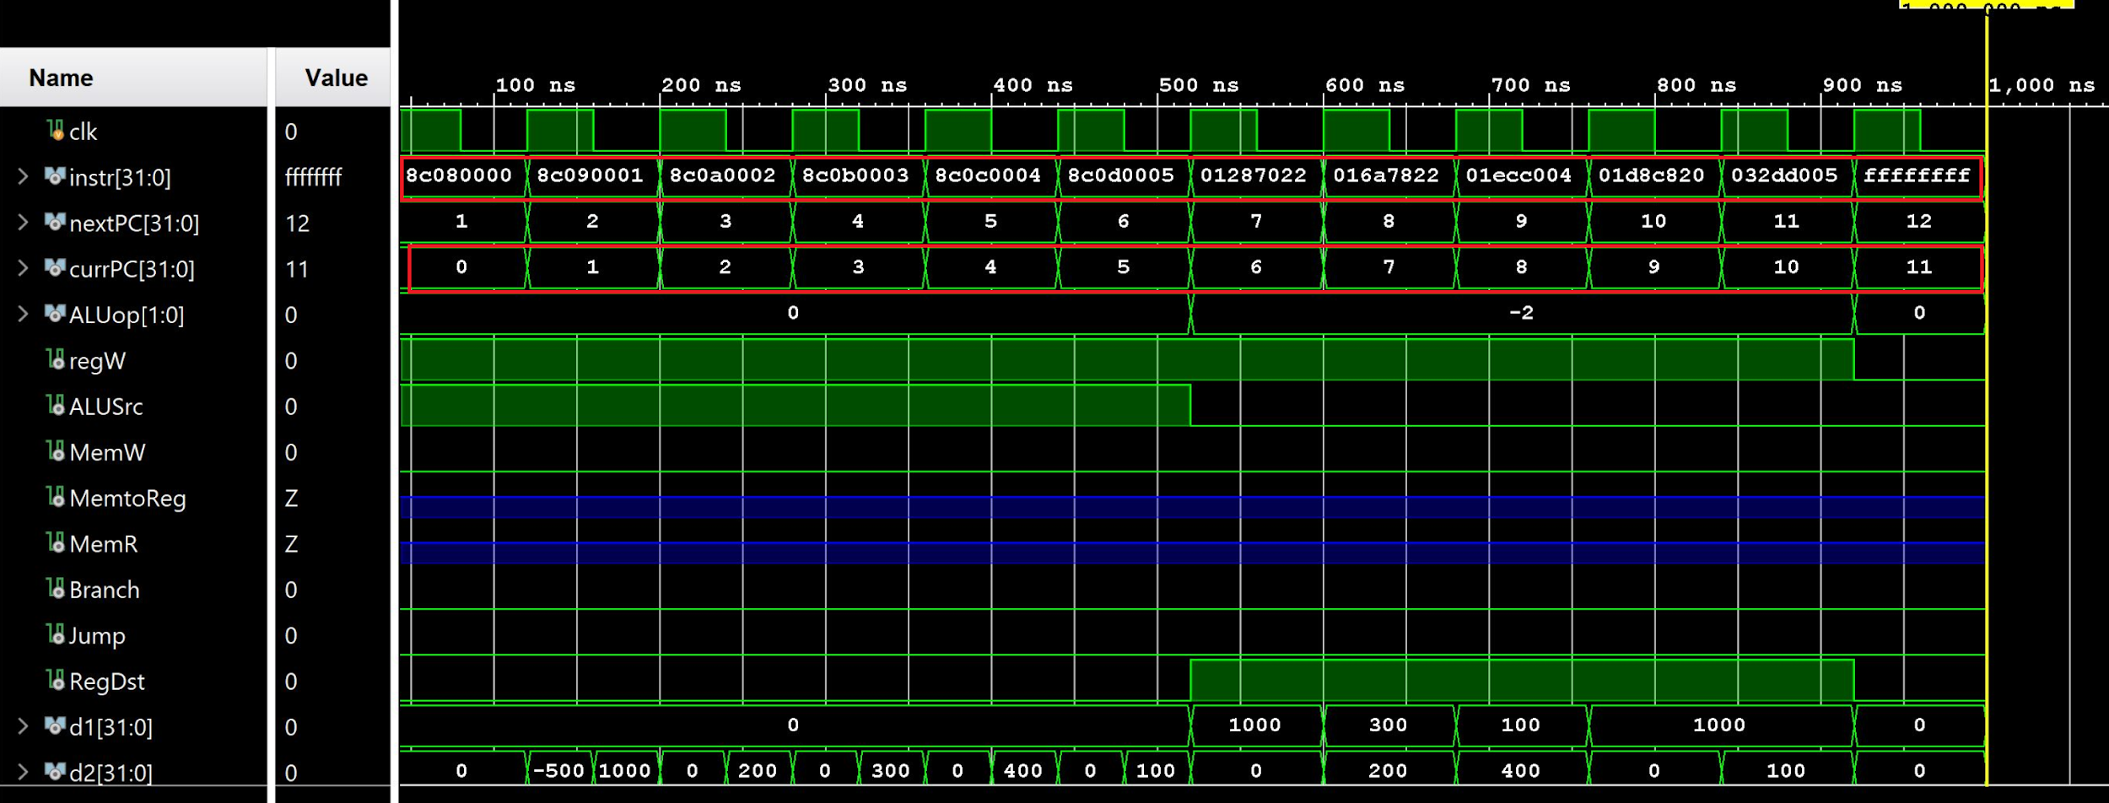

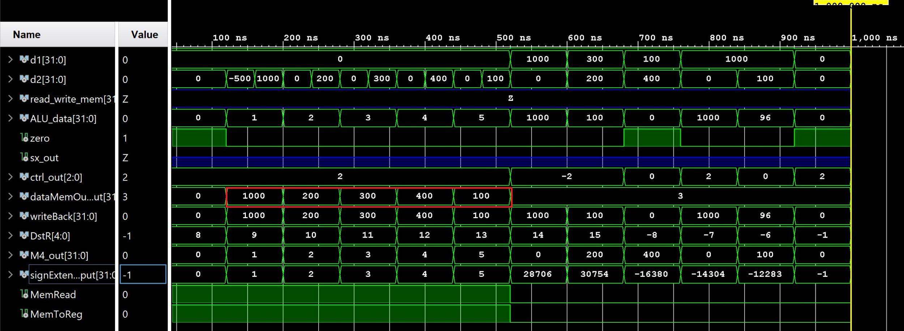

**Conclusions:**

The overall design specifics were met to a great extent. We have successfully created all the individual modules of the single-cycle processor. Although we were able to simulate the testbenches of all of the required submodules and achieve the desired outputs, we were unable to achieve the result of our given expression after running the top-level processor module. This may be due to errors in the instantiations of our submodules, since all of our submodules functioned well individually. The Xilinx IDE has also been inconsistent with some of its running files which led us to use the Vivado IDE to create certain programs during the compilation stage of the entire program. Nonetheless, we have been able to achieve most of our desired outputs as the data and instructions were correctly loaded into the program. Future developments of this project include debugging the instantiation of the assembly of the entire design in order to evaluate the final expression. Had we been able to have extended time, we would have fixed this issue and get the final result of the calculation displayed. In conclusion, the project had been an essential learning experience in learning about the single-cycle processor.